






Work in a socially diverse environment
D1.HRS.CL1.19
D1.HOT.CL1.02
D2.TCC.CL1.02
Trainer Guide

Work in a socially diverse environment

D1.HRS.CL1.19
D1.HOT.CL1.02
D2.TCC.CL1.02

Trainer Guide




Project Base
William Angliss Institute of TAFE
555 La Trobe Street
Melbourne 3000 Victoria
Telephone: | (03) 9606 2111
Facsimile: | (03) 9670 1330
Acknowledgements
Project Director: | Wayne Crosbie
Chief Writer: | Alan Hickman
Subject Writer: | Jim Irwin
Project Manager/Editor: | Alan Maguire
DTP/Production | Daniel Chee, Mai Vu, Jirayu Thangcharoensamut, Kaly Quach

The Association of Southeast Asian Nations (ASEAN) was established on 8 August 1967. The Member States of the Association are Brunei Darussalam, Cambodia, Indonesia, Lao PDR, Malaysia, Myanmar, Philippines, Singapore, Thailand and Viet Nam.
The ASEAN Secretariat is based in Jakarta, Indonesia.
General Information on ASEAN appears online at the ASEAN Website: www.asean.org.
All text is produced by William Angliss Institute of TAFE for the ASEAN Project on “Toolbox Development for Priority Tourism Labour Division”.
This publication is supported by the Australian Government’s aid program through the ASEAN-Australia Development Cooperation Program Phase II (AADCP II).
Copyright: Association of Southeast Asian Nations (ASEAN) 2012.
All rights reserved.
Disclaimer
Every effort has been made to ensure that this publication is free from errors or omissions. However, you should conduct your own enquiries and seek professional advice before relying on any fact, statement or matter contained in this book. The ASEAN Secretariat and William Angliss Institute of TAFE are not responsible for any injury, loss or damage as a result of material included or omitted from this course. Information in this module is current at the time of publication. Time of publication is indicated in the date stamp at the bottom of each page.
Some images appearing in this resource have been purchased from stock photography suppliers Shutterstock and iStockphoto and other third party copyright owners and as such are non-transferable and non-exclusive. Clip arts, font images and illustrations used are from the Microsoft Office Clip Art and Media Library. Some images have been provided by and are the property of William Angliss Institute.
Additional images have been sourced from Flickr and SXC and are used under Creative Commons licence: http://creativecommons.org/licenses/by/2.0/deed.en

File name: TG_Work_in_a_socially_diverse_environment_refined.docx





Table of contents
Competency Based Training (CBT) and assessment an introduction for trainers 1
Competency standard 11
Notes and PowerPoint slides 17
Recommended training equipment 91
Instructions for Trainers for using PowerPoint – Presenter View 93
Appendix – ASEAN acronyms 95

Competency Based Training (CBT) and assessment an introduction for trainers

Competency
Competency refers to the ability to perform particular tasks and duties to the standard of performance expected in the workplace.
Competency requires the application of specified knowledge, skills and attitudes relevant to effective participation, consistently over time and in the workplace environment.
The essential skills and knowledge are either identified separately or combined.
Knowledge identifies what a person needs to know to perform the work in an informed and effective manner.
Skills describe the application of knowledge to situations where understanding is converted into a workplace outcome.
Attitude describes the founding reasons behind the need for certain knowledge or why skills are performed in a specified manner.
Competency covers all aspects of workplace performance and involves:
- Performing individual tasks
- Managing a range of different tasks
- Responding to contingencies or breakdowns
- Dealing with the responsibilities of the workplace
- Working with others.

Unit of Competency
Like with any training qualification or program, a range of subject topics are identified that focus on the ability in a certain work area, responsibility or function.
Each manual focuses on a specific unit of competency that applies in the hospitality workplace.
In this manual a unit of competency is identified as a ‘unit’.
Each unit of competency identifies a discrete workplace requirement and includes:
- Knowledge and skills that underpin competency
- Language, literacy and numeracy
- Occupational safety and health requirements.
Each unit of competency must be adhered to in training and assessment to ensure consistency of outcomes.

Element of Competency
An element of competency describes the essential outcomes within a unit of competency.
The elements of competency are the basic building blocks of the unit of competency. They describe in terms of outcomes the significant functions and tasks that make up the competency.
In this manual elements of competency are identified as an ‘element’.

Performance criteria
Performance criteria indicate the standard of performance that is required to demonstrate achievement within an element of competency. The standards reflect identified industry skill needs.
Performance criteria will be made up of certain specified skills, knowledge and attitudes.

Learning
For the purpose of this manual learning incorporates two key activities:
- Training
- Assessment.
Both of these activities will be discussed in detail in this introduction.
Today training and assessment can be delivered in a variety of ways. It may be provided to participants:
- On-the-job – in the workplace
- Off-the-job – at an educational institution or dedicated training environment
- As a combination of these two options.
No longer is it necessary for learners to be absent from the workplace for long periods of time in order to obtain recognised and accredited qualifications.

Learning Approaches
This manual will identify two avenues to facilitate learning:
Competency Based Training (CBT)
This is the strategy of developing a participant’s competency.
Educational institutions utilise a range of training strategies to ensure that participants are able to gain the knowledge and skills required for successful:
- Completion of the training program or qualification
- Implementation in the workplace.
The strategies selected should be chosen based on suitability and the learning styles of participants.

Competency Based Assessment (CBA)
This is the strategy of assessing competency of a participant.
Educational institutions utilise a range of assessment strategies to ensure that participants are assessed in a manner that demonstrates validity, fairness, reliability, flexibility and fairness of assessment processes.

Flexibility in Learning
It is important to note that flexibility in training and assessment strategies is required to meet the needs of participants who may have learning difficulties. The strategies used will vary, taking into account the needs of individual participants with learning difficulties. However they will be applied in a manner which does not discriminate against the participant or the participant body as a whole.
Catering for Participant Diversity
Participants have diverse backgrounds, needs and interests. When planning training and assessment activities to cater for individual differences, trainers and assessors should:
- Consider individuals’ experiences, learning styles and interests
- Develop questions and activities that are aimed at different levels of ability
- Modify the expectations for some participants
- Provide opportunities for a variety of forms of participation, such as individual, pair and small group activities
- Assess participants based on individual progress and outcomes.
The diversity among participants also provides a good reason for building up a learning community in which participants support each other’s learning.
Participant Centred Learning
This involves taking into account structuring training and assessment that:
- Builds on strengths – Training environments need to demonstrate the many positive features of local participants (such as the attribution of academic success to effort, and the social nature of achievement motivation) and of their trainers (such as a strong emphasis on subject disciplines and moral responsibility). These strengths and uniqueness of local participants and trainers should be acknowledged and treasured
- Acknowledges prior knowledge and experience – The learning activities should be planned with participants’ prior knowledge and experience in mind
- Understands learning objectives – Each learning activity should have clear learning objectives and participants should be informed of them at the outset. Trainers should also be clear about the purpose of assignments and explain their significance to participants
- Teaches for understanding – The pedagogies chosen should aim at enabling participants to act and think flexibly with what they know
- Teaches for independent learning – Generic skills and reflection should be nurtured through learning activities in appropriate contexts of the curriculum. Participants should be encouraged to take responsibility for their own learning
- Enhances motivation – Learning is most effective when participants are motivated. Various strategies should be used to arouse the interest of participants
- Makes effective use of resources – A variety of teaching resources can be employed as tools for learning
- Maximises engagement – In conducting learning activities, it is important for the minds of participants to be actively engaged
- Aligns assessment with learning and teaching – Feedback and assessment should be an integral part of learning and teaching
- Caters for learner diversity – Trainers should be aware that participants have different characteristics and strengths and try to nurture these rather than impose a standard set of expectations.
Active Learning
The goal of nurturing independent learning in participants does not imply that they always have to work in isolation or solely in a classroom. On the contrary, the construction of knowledge in tourism and hospitality studies can often best be carried out in collaboration with others in the field. Sharing experiences, insights and views on issues of common concern, and working together to collect information through conducting investigative studies in the field (active learning) can contribute a lot to their eventual success.
Active learning has an important part to play in fostering a sense of community in the class. First, to operate successfully, a learning community requires an ethos of acceptance and a sense of trust among participants, and between them and their trainers. Trainers can help to foster acceptance and trust through encouragement and personal example, and by allowing participants to take risks as they explore and articulate their views, however immature these may appear to be. Participants also come to realise that their classmates (and their trainers) are partners in learning and solving.
Trainers can also encourage cooperative learning by designing appropriate group learning tasks, which include, for example, collecting background information, conducting small-scale surveys, or producing media presentations on certain issues and themes. Participants need to be reminded that, while they should work towards successful completion of the field tasks, developing positive peer relationships in the process is an important objective of all group work.

Competency Based Training (CBT)
Principle of Competency Based Training
Competency based training is aimed at developing the knowledge, skills and attitudes of participants, through a variety of training tools.
Training Strategies
The aims of this curriculum are to enable participants to:
- Undertake a variety of subject courses that are relevant to industry in the current environment
- Learn current industry skills, information and trends relevant to industry
- Learn through a range of practical and theoretical approaches
- Be able to identify, explore and solve issues in a productive manner
- Be able to become confident, equipped and flexible managers of the future
- Be ‘job ready’ and a valuable employee in the industry upon graduation of any qualification level.
To ensure participants are able to gain the knowledge and skills required to meet competency in each unit of competency in the qualification, a range of training delivery modes are used.
Types of Training
In choosing learning and teaching strategies, trainers should take into account the practical, complex and multi-disciplinary nature of the subject area, as well as their participant’s prior knowledge, learning styles and abilities.
Training outcomes can be attained by utilising one or more delivery methods:
Lecture/Tutorial
This is a common method of training involving transfer of information from the trainer to the participants. It is an effective approach to introduce new concepts or information to the learners and also to build upon the existing knowledge. The listener is expected to reflect on the subject and seek clarifications on the doubts.
Demonstration
Demonstration is a very effective training method that involves a trainer showing a participant how to perform a task or activity. Through a visual demonstration, trainers may also explain reasoning behind certain actions or provide supplementary information to help facilitate understanding.
Group Discussions
Brainstorming in which all the members in a group express their ideas, views and opinions on a given topic, is a free flow and exchange of knowledge among the participants and the trainer. The discussion is carried out by the group on the basis of their own experience, perceptions and values. This will facilitate acquiring new knowledge. When everybody is expected to participate in the group discussion, even the introverted persons will also get stimulated and try to articulate their feelings.
The ideas that emerge in the discussions should be noted down and presentations are to be made by the groups. Sometimes consensus needs to be arrived at on a given topic. Group discussions are to be held under the moderation of a leader guided by the trainer. Group discussion technique triggers thinking process, encourages interactions and enhances communication skills.
Role Play
This is a common and very effective method of bringing into the classroom real life situations, which may not otherwise be possible. Participants are made to enact a particular role so as to give a real feel of the roles they may be called upon to play. This enables participants to understand the behaviour of others as well as their own emotions and feelings. The instructor must brief the role players on what is expected of them. The role player may either be given a ready-made script, which they can memorise and enact, or they may be required to develop their own scripts around a given situation. This technique is extremely useful in understanding creative selling techniques and human relations. It can be entertaining and energising and it helps the reserved and less literate to express their feelings.

Simulation Games
When trainees need to become aware of something that they have not been conscious of, simulations can be a useful mechanism. Simulation games are a method based on "here and now" experience shared by all the participants. The games focus on the participation of the trainees and their willingness to share their ideas with others. A "near real life" situation is created providing an opportunity to which they apply themselves by adopting certain behaviour. They then experience the impact of their behaviour on the situation. It is carried out to generate responses and reactions based on the real feelings of the participants, which are subsequently analysed by the trainer.
While use of simulation games can result in very effective learning, it needs considerable trainer competence to analyse the situations.
Individual /Group Exercises
Exercises are often introduced to find out how much the participant has assimilated. This method involves imparting instructions to participants on a particular subject through use of written exercises. In the group exercises, the entire class is divided into small groups, and members are asked to collaborate to arrive at a consensus or solution to a problem.
Case Study
This is a training method that enables the trainer and the participant to experience a real life situation. It may be on account of events in the past or situations in the present, in which there may be one or more problems to be solved and decisions to be taken. The basic objective of a case study is to help participants diagnose, analyse and/or solve a particular problem and to make them internalise the critical inputs delivered in the training. Questions are generally given at the end of the case study to direct the participants and to stimulate their thinking towards possible solutions. Studies may be presented in written or verbal form.
Field Visit
This involves a carefully planned visit or tour to a place of learning or interest. The idea is to give first-hand knowledge by personal observation of field situations, and to relate theory with practice. The emphasis is on observing, exploring, asking questions and understanding. The trainer should remember to brief the participants about what they should observe and about the customs and norms that need to be respected.
Group Presentation
The participants are asked to work in groups and produce the results and findings of their group work to the members of another sub-group. By this method participants get a good picture of each other's views and perceptions on the topic and they are able to compare them with their own point of view. The pooling and sharing of findings enriches the discussion and learning process.
Practice Sessions
This method is of paramount importance for skills training. Participants are provided with an opportunity to practice in a controlled situation what they have learnt. It could be real life or through a make-believe situation.

Games
This is a group process and includes those methods that involve usually fun-based activity, aimed at conveying feelings and experiences, which are everyday in nature, and applying them within the game being played. A game has set rules and regulations, and may or may not include a competitive element. After the game is played, it is essential that the participants be debriefed and their lessons and experiences consolidated by the trainer.
Research
Trainers may require learners to undertake research activities, including online research, to gather information or further understanding about a specific subject area.

Competency Based Assessment (CBA)
Principle of Competency Based Assessment
Competency based assessment is aimed at compiling a list of evidence that shows that a person is competent in a particular unit of competency.
Competencies are gained through a multitude of ways including:
- Training and development programs
- Formal education
- Life experience
- Apprenticeships
- On-the-job experience
- Self-help programs.
All of these together contribute to job competence in a person. Ultimately, assessors and participants work together, through the ‘collection of evidence’ in determining overall competence.
This evidence can be collected:
- Using different formats
- Using different people
- Collected over a period of time.
The assessor, who is ideally someone with considerable experience in the area being assessed, reviews the evidence and verifies the person as being competent or not.
Flexibility in Assessment
Whilst allocated assessment tools have been identified for this subject, all attempts are made to determine competency and suitable alternate assessment tools may be used, according to the requirements of the participant.
The assessment needs to be equitable for all participants, taking into account their cultural and linguistic needs.
Competency must be proven regardless of:
- Language
- Delivery Method
- Assessment Method.
Assessment Objectives
The assessment tools used for subjects are designed to determine competency against the ‘elements of competency’ and their associated ‘performance criteria’.
The assessment tools are used to identify sufficient:
- Knowledge, including underpinning knowledge
- Skills
- Attitudes
Assessment tools are activities that trainees are required to undertake to prove participant competency in this subject.
All assessments must be completed satisfactorily for participants to obtain competence in this subject. There are no exceptions to this requirement, however, it is possible that in some cases several assessment items may be combined and assessed together.
Types of Assessment
Allocated Assessment Tools
There are a number of assessment tools that are used to determine competency in this subject:
- Work projects
- Written questions
- Oral questions
- Third Party Report
- Observation Checklist.
Instructions on how assessors should conduct these assessment methods are explained in the Assessment Manuals.
Alternative Assessment Tools
Whilst this subject has identified assessment tools, as indicated above, this does not restrict the assessor from using different assessment methods to measure the competency of a participant.
Evidence is simply proof that the assessor gathers to show participants can actually do what they are required to do.
Whilst there is a distinct requirement for participants to demonstrate competency, there are many and diverse sources of evidence available to the assessor.
Ongoing performance at work, as verified by a supervisor or physical evidence, can count towards assessment. Additionally, the assessor can talk to customers or work colleagues to gather evidence about performance.
A range of assessment methods to assess competency include:
- Practical demonstrations
- Practical demonstrations in simulated work conditions
- Problem solving
- Portfolios of evidence
- Critical incident reports
- Journals
- Oral presentations
- Interviews
- Videos
- Visuals: slides, audio tapes
- Case studies
- Log books
- Projects
- Role plays
- Group projects
- Group discussions
- Examinations.
Recognition of Prior Learning
Recognition of Prior Learning is the process that gives current industry professionals who do not have a formal qualification, the opportunity to benchmark their extensive skills and experience against the standards set out in each unit of competency/subject.
Also known as a Skills Recognition Audit (SRA), this process is a learning and assessment pathway which encompasses:
- Recognition of Current Competencies (RCC)
- Skills auditing
- Gap analysis and training
- Credit transfer.
Assessing competency
As mentioned, assessment is the process of identifying a participant’s current knowledge, skills and attitudes sets against all elements of competency within a unit of competency. Traditionally in education, grades or marks were given to participants, dependent on how many questions the participant successfully answered in an assessment tool.
Competency based assessment does not award grades, but simply identifies if the participant has the knowledge, skills and attitudes to undertake the required task to the specified standard.
Therefore, when assessing competency, an assessor has two possible results that can be awarded:
- Pass Competent (PC)
- Not Yet Competent (NYC).
Pass Competent (PC)
If the participant is able to successfully answer or demonstrate what is required, to the expected standards of the performance criteria, they will be deemed as ‘Pass Competent’ (PC).
The assessor will award a ‘Pass Competent’ (PC) if they feel the participant has the necessary knowledge, skills and attitudes in all assessment tasks for a unit.
Not Yet Competent’ (NYC)
If the participant is unable to answer or demonstrate competency to the desired standard, they will be deemed to be ‘Not Yet Competent’ (NYC).
This does not mean the participant will need to complete all the assessment tasks again. The focus will be on the specific assessment tasks that were not performed to the expected standards.
The participant may be required to:
a) Undertake further training or instruction
b) Undertake the assessment task again until they are deemed to be ‘Pass Competent’.

Competency standard
UNIT TITLE: WORK IN A SOCIALLY DIVERSE ENVIRONMENT |  | NOMINAL HOURS: 25 hours
UNIT NUMBER: D1.HRS.CL1.19; D1.HOT.CL1.02; D2.TCC.CL1.02
UNIT DESCRIPTOR: This unit deals with the skills and knowledge required to work effectively in a socially diverse environment in a range of settings within the hotel and travel industries workplace context.
ELEMENTS AND PERFORMANCE CRITERIA | UNIT VARIABLE AND ASSESSMENT GUIDE
Element 1: Communicate with customers and colleagues from diverse backgrounds  - Value customers and colleagues from different cultural groups and treat them with respect and sensitivity  - Take into consideration cultural differences in all verbal and non-verbal communication  - Attempt to overcome language barriers  - Obtain assistance from colleagues, reference books or outside organisations when required  Element 2: Deal with cross cultural Misunderstandings  - Identify issues which may cause conflict or misunderstanding in the workplace  - Address difficulties with the appropriate people and seek assistance from team leaders or others where required  - Consider possible cultural differences when difficulties or misunderstandings occur  - Make efforts to resolve misunderstandings, taking account of cultural considerations  - Refer issues and problems to the appropriate team leader/supervisor for follow up | Unit Variables  The Unit Variables provide advice to interpret the scope and context of this unit of competence, allowing for differences between enterprises and workplaces. It relates to the unit as a whole and facilitates holistic assessment  This unit applies to all industry sectors that seek to work in a socially diverse environment within the labour divisions of the hotel and travel industries and may include:  - Front Office  - Housekeeping  - Food and Beverage Service  - Food Production  - Travel Agencies  - Tour Operation.  Cultural differences may include:  Forms of address  Levels of formality/informality  Non-verbal behaviour  Work ethics  Personal grooming
Family obligations
Recognized holidays
Special needs
Preferences for personal interactions.
Attempt to overcome language barriers may include:
Use simple gestures
Use simple words
Use words in the other person’s language
Describe goods and services simply
Use diagrams or maps to give simple directions.
Assistance may include:
Co-workers who speak the same language
Interpreter services
Diplomatic services
Supervisors, or managers, or specialist customer service staff within the enterprise.
Issues which may cause conflict may include:
Competing group, family or personal interests
Power and control issues
Lack of communication
Personality clashes
Cross-cultural issues
Differences between cultural groups
Dissatisfaction in the community
Competing needs.
Misunderstandings in the workplace including:
Speaking too quickly/quietly
No visual clues
Poor observation
Poor communication style
Intolerance
Prejudice
Inadequate language skills
Not clarifying or asking questions
Inappropriate body language
Poor understanding of other cultures.
Resolve misunderstandings may relate to:
Staff training
Utilising staff cultural skills
Employing a variety of communication methods
Knowledge of location of cultural buildings sites and support agencies
Developing an understanding and tolerance of cultural diversity
Overcoming prejudice and assumptions
Utilising non-verbal communication skills
Actively seeking to break down barriers.
Assessment Guide
The following skills and knowledge must be assessed as part of this unit:
Knowledge of the principles of effective communication skills
Ability to identify the need(s) and concerns of others
Ability to use active listening, feedback techniques and team building techniques to build and maintain interpersonal relationships with customers and colleagues from diverse backgrounds
Ability to communicate effectively with a range of people from diverse backgrounds relevant to position and role
Ability to appropriately deal with cross cultural misunderstandings.
Linkages To Other Units
This is a core unit that underpins effective performance in all other units; combined training and assessment may be appropriate.
Critical Aspects of Assessment
Evidence of the following is essential:
Demonstrated ability to apply active listening techniques
Demonstrated ability to use effective communication skills to build and maintain interpersonal relationships with customers and colleagues from diverse backgrounds
Demonstrated ability to maintain effective communication with customers and colleagues from diverse backgrounds
Demonstrated ability to communicate effectively with customers and colleagues from diverse backgrounds
Demonstrated ability to deal with cross-cultural misunderstandings
Observation that verbal and non-verbal communication takes account of cultural differences
Demonstrated commitment to include and/or communicate with others where language barriers exist
Demonstrated ability to apply knowledge of different cultures and cultural characteristics appropriately in communications with customers and colleagues from diverse backgrounds.
Context of Assessment
This unit may be assessed on or off the job:
Assessment should include practical demonstration either in the workplace or through a simulation activity, supported by a range of methods to assess underpinning knowledge
Assessment must relate to the individual’s work area or area of responsibility.
Resource Implications
Training and assessment to include access to a real or simulated workplace; and access to workplace standards, procedures, policies, guidelines, tools and equipment.
Assessment Methods
The following methods may be used to assess competency for this unit:
Case studies
Observation of practical candidate performance
Oral and written questions
Portfolio evidence
Problem solving
Role plays
Third party reports completed by a supervisor
Project and assignment work.

Key Competencies in this Unit
Level 1 = competence to undertake tasks effectively
Level 2 = competence to manage tasks
Level 3 = competence to use concepts for evaluating
 | Key Competencies | Level | Examples
 | Collecting, organising and analysing information | 1 | Identify different cultural beliefs and values
 | Communicating ideas and information | 2 | Explain how to do something to a colleague or customer from another language or cultural background
 | Planning and organising activities | 2 | Identify ways to improve workplace communication with colleagues/customers from diverse backgrounds
 | Working with others and in teams | 2 | Work cooperatively with team members from diverse backgrounds
 | Using mathematical ideas and techniques | 0
 | Solving problems | 2 | Applying conflict resolution and communication skills to resolve conflict and/or misunderstandings
 | Using technology | 0

Notes and PowerPoint slides
Slide

Slide No | Trainer Notes
 | Trainer welcomes trainees to class.

Slide
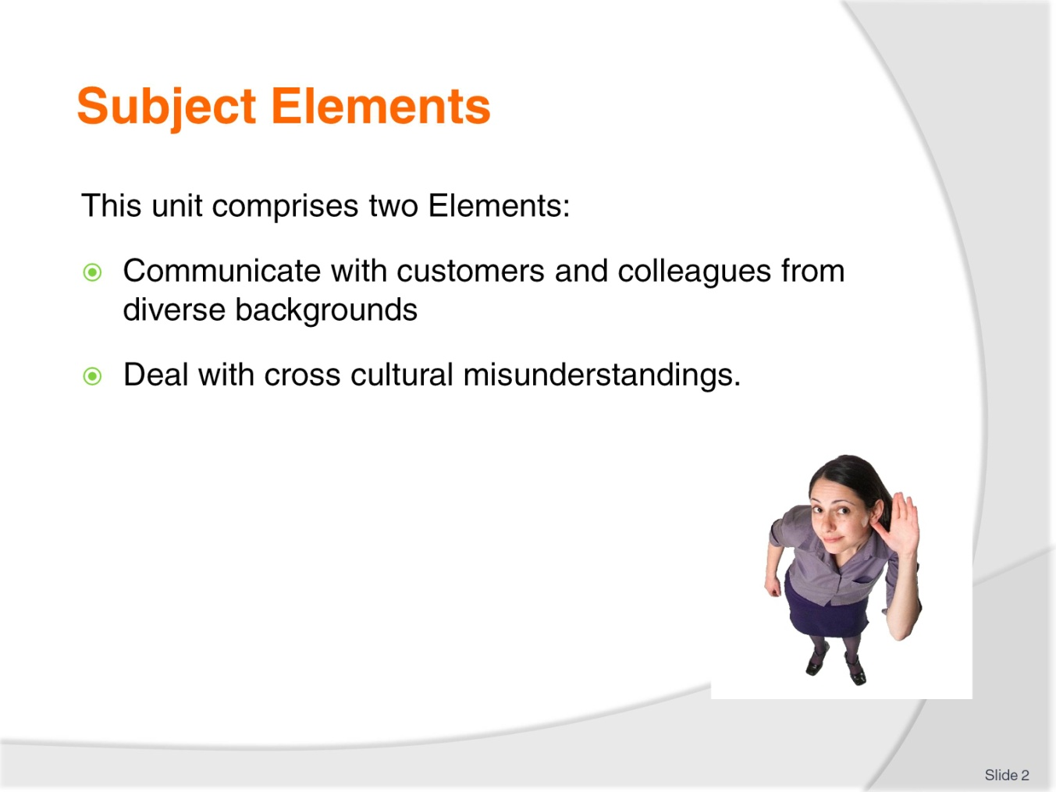
Slide No | Trainer Notes
Trainer advises this Unit comprises two Elements, as listed on the slide explaining:
Each Element comprises a number of Performance Criteria which will be identified throughout the class and explained in detail
Trainees can obtain more detail from their Trainee Manual
At times the course presents advice and information about various protocols but where their workplace requirements differ to what is presented, the workplace practices and standards, as well as policies and procedures must be observed.

Slide
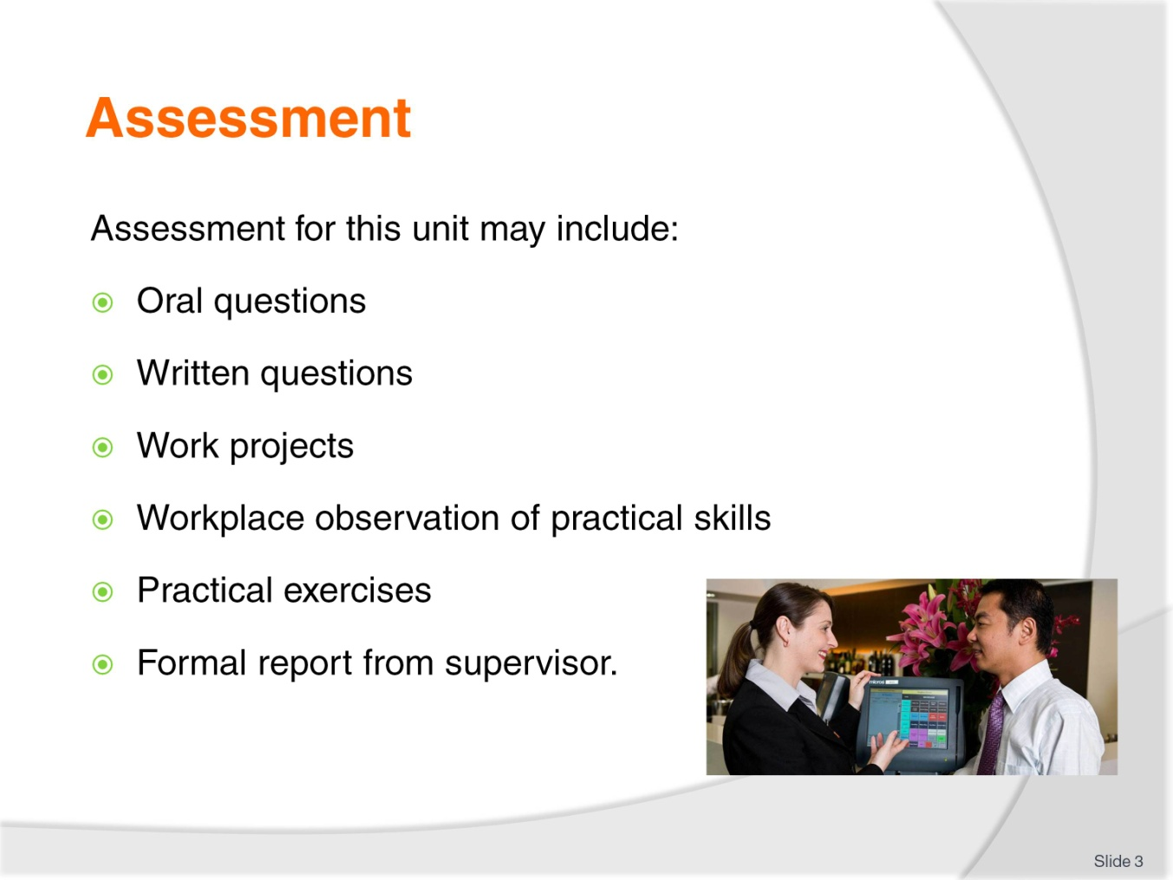
Slide No | Trainer Notes
Trainer advises that assessment for this Unit may take several forms all of which are aimed at verifying they have achieved competency for the Unit as required.
Trainer indicates the methods of assessment that will be applied to them for this Unit.

Slide
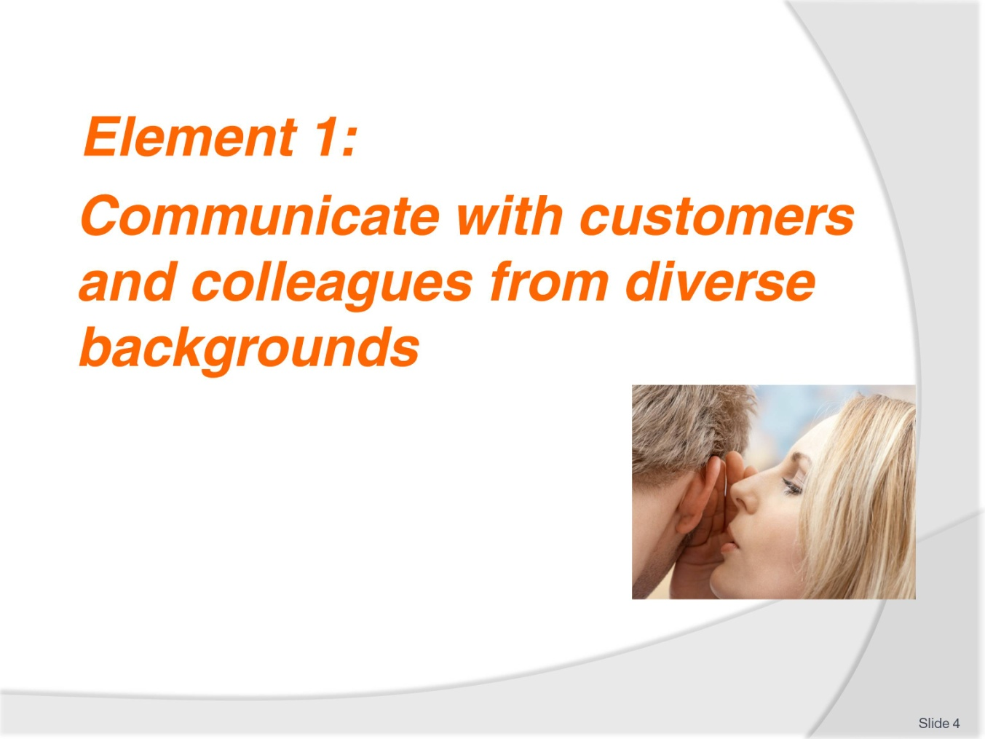
Slide No | Trainer Notes
Introduce topic
Class Activity – General Discussion
Ask general questions:
What is communication?
Why is communication important?
What information do you communicate with customers – both internal and external?
What challenges exist when communicating with people from diverse backgrounds?

Slide
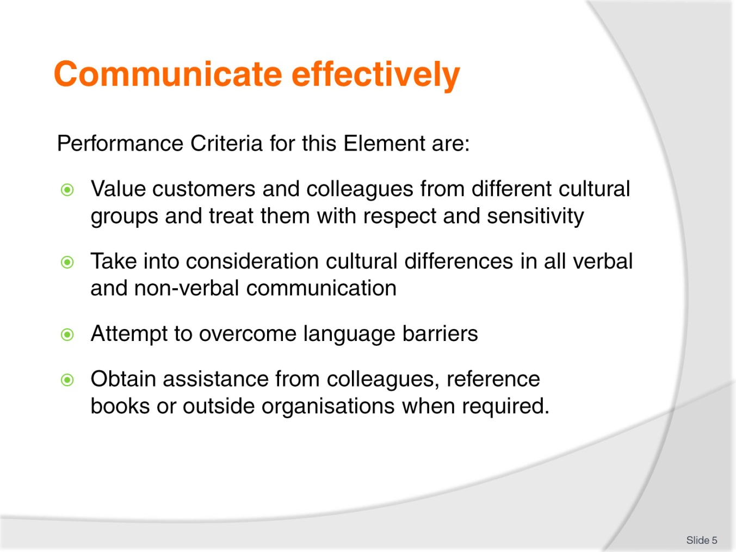
Slide No | Trainer Notes
 | Trainer identifies the Performance Criteria for this Element, as listed on the slide.

Slide
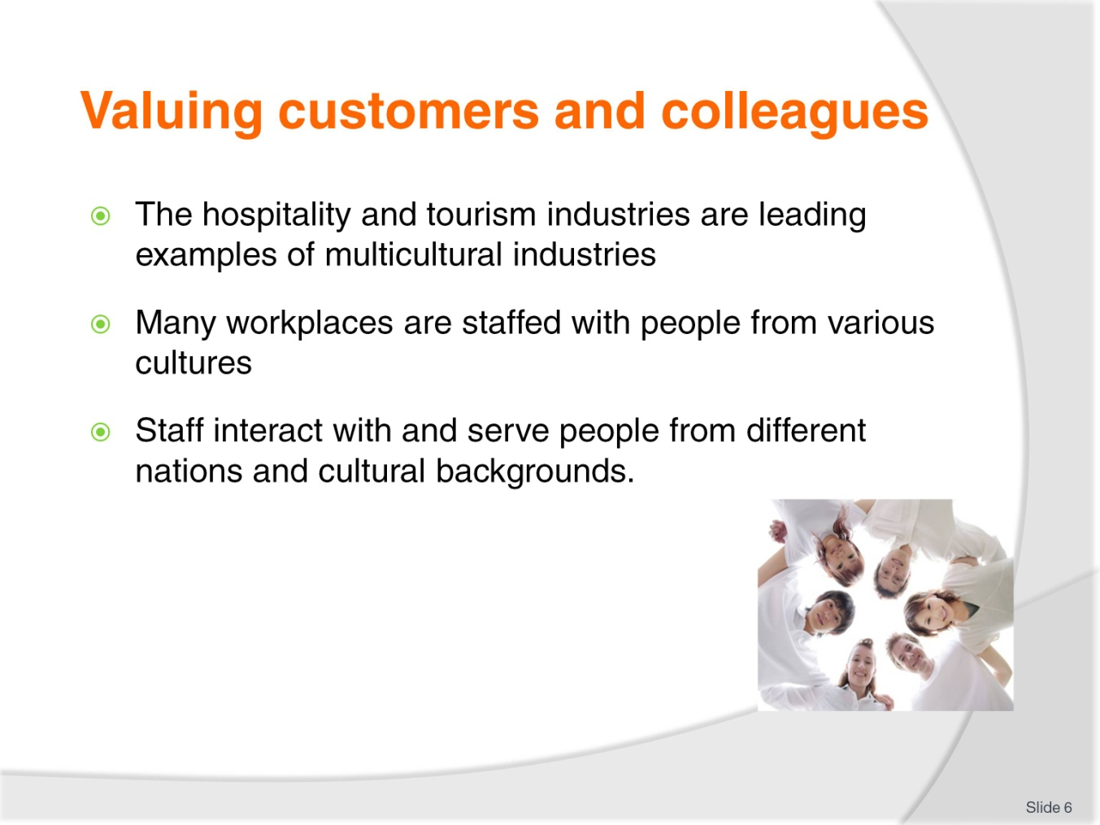
Slide No | Trainer Notes
Class Activity – General Discussion
Trainer leads a general class discussion how diverse a hospitality environment is:
Staff – What diversity exists in your business in regards to staff? What countries do they come from? What different cultures exist?
Customers – What diversity exists in your business in regards to customers? What countries do they come from? What different cultures exist? What languages do they speak?

Slide
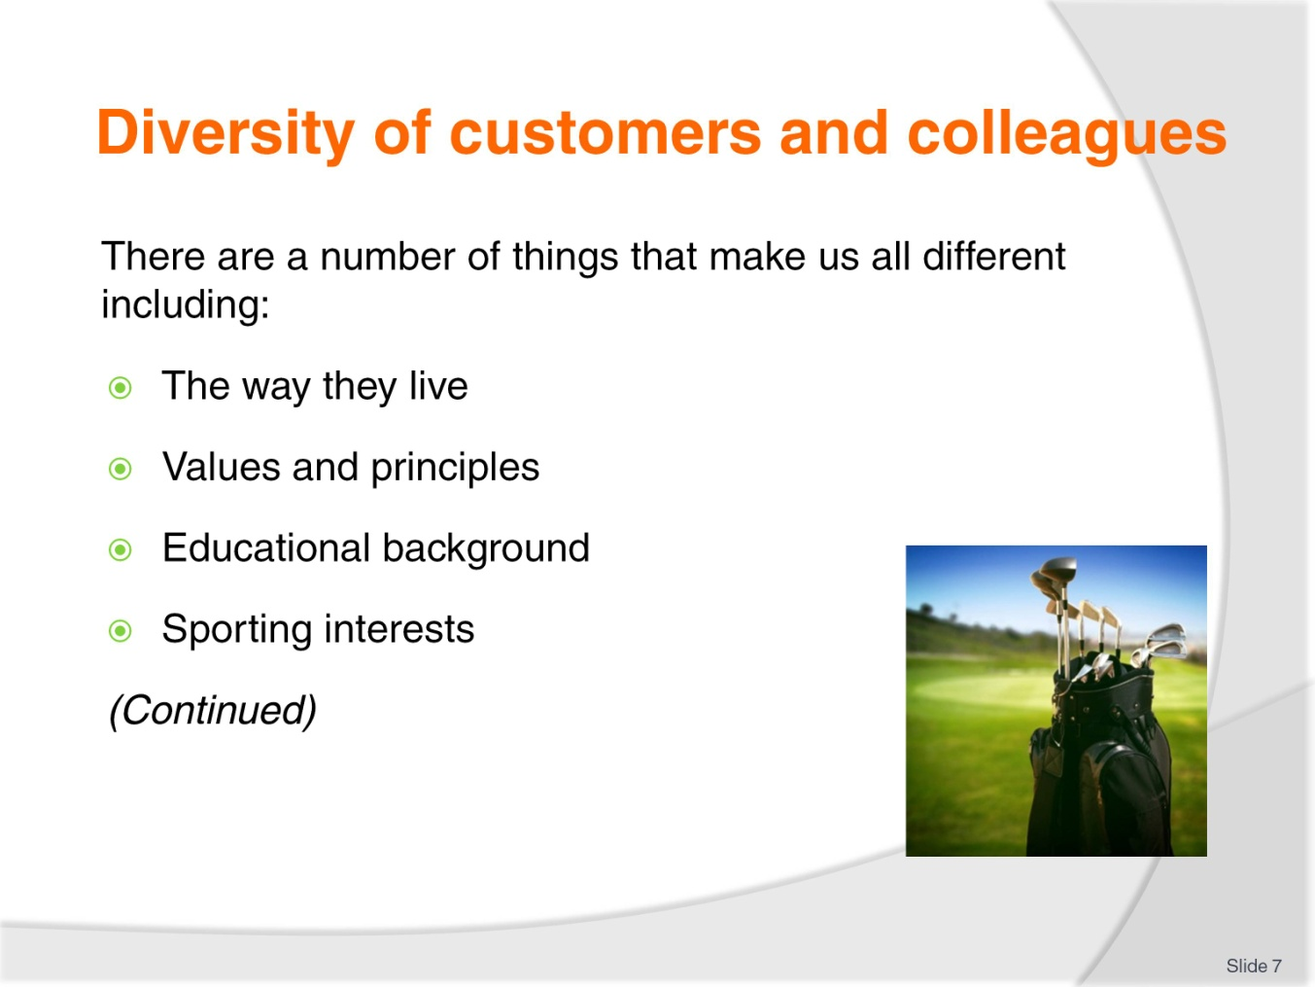
Slide No | Trainer Notes
The way they live – including where and how they live.
Values and principles – the importance placed on people, actions and things, and personal guidelines for living life.
Educational background – how far they got through schooling, and whether or not they did any further education.
Sporting interests – whether they play sport, or whether they are even interested in sport: and which sport.
Class Activity – General Discussion & Exercise (incorporates this and next slide)
Discuss the diversity of the audience in relation to these points. Write the answers down on the board.
You will find a great amount of diversity just amongst this group. Imagine the expanse of diversity given all the staff and customers in a typical hospitality business.
Given the list you have developed, what can a hospitality business do to help cater to these cultural differences?

Slide
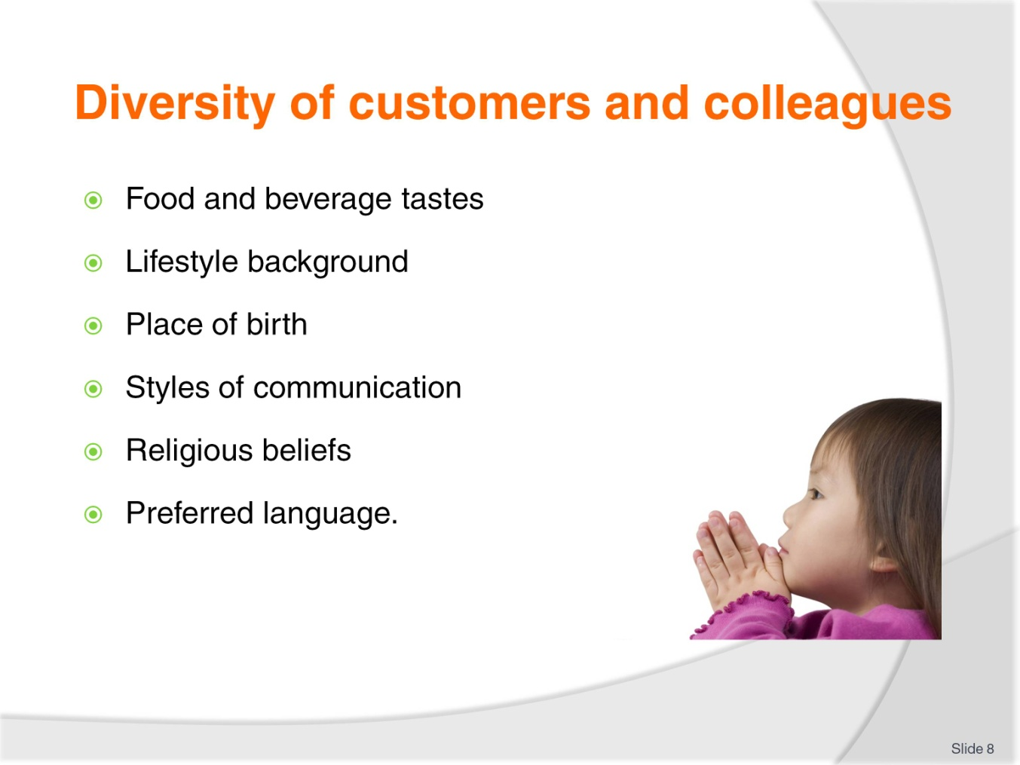
Slide No | Trainer Notes
Food and beverage tastes – do they drink alcohol or prefer juice, do they eat red meat or are they vegetarian?
Lifestyle background – what car do they drive, where have they worked?
Place of birth – which country where they born in?
Styles of communication – what is their preferred communication medium and method?
Religious beliefs – who or what do they believe in?
What is their preferred language?
Class Activity – General Discussion & Exercise (incorporates this and past slide)
Discuss the diversity of the audience in relation to these points. Write the answers down on the board.
You will find a great amount of diversity just amongst this group. Imagine the expanse of diversity given all the staff and customers in a typical hospitality business.
Given the list you have developed, what can a hospitality business do to help cater to these cultural differences?

Slide
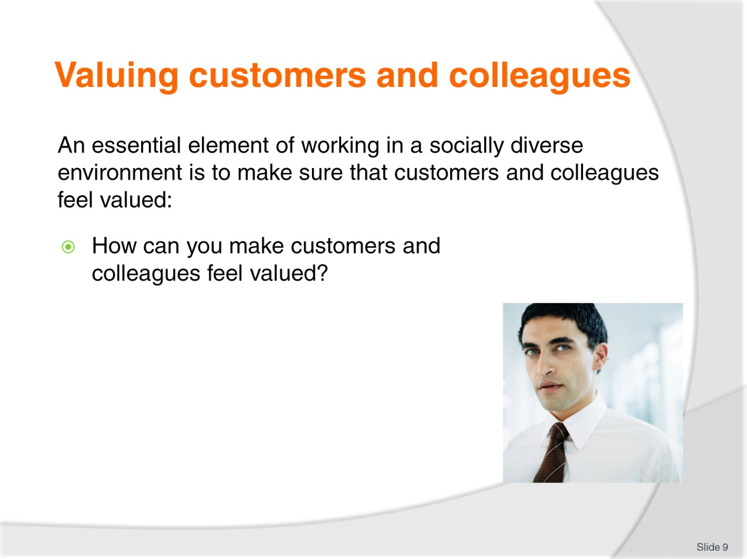
Slide No | Trainer Notes
Class Activity – General Discussion
Answer question in slide
Is there a different approach you need to take when dealing with customers as opposed to colleagues?

Slide
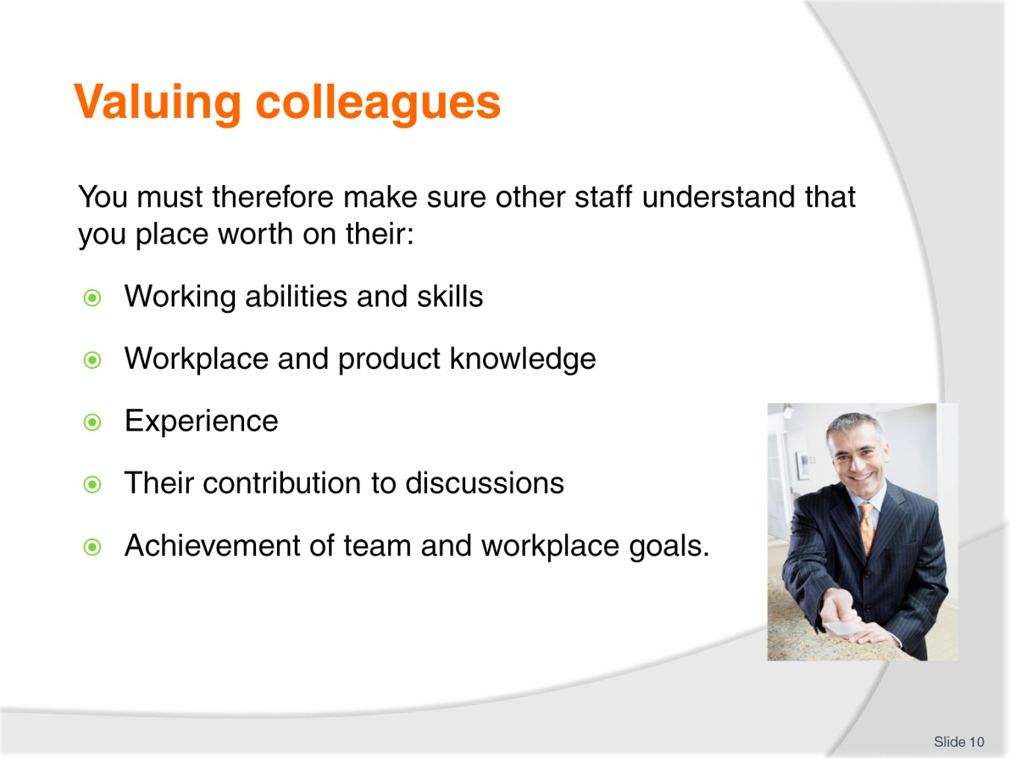
Slide No | Trainer Notes
Class Activity – General Discussion
How do you show you value colleagues?

Slide
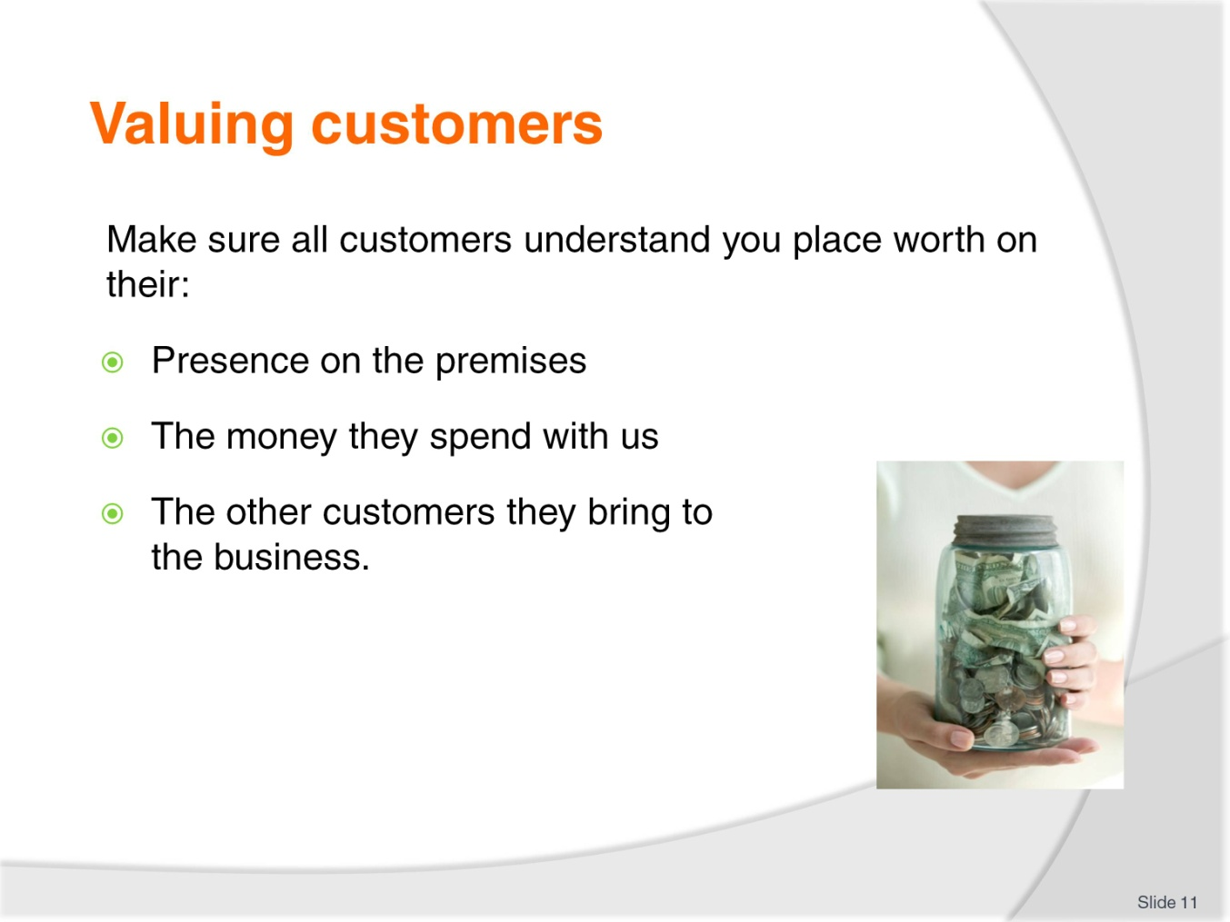
Slide No | Trainer Notes
Class Activity – General Discussion
How do you show you value customers?

Slide
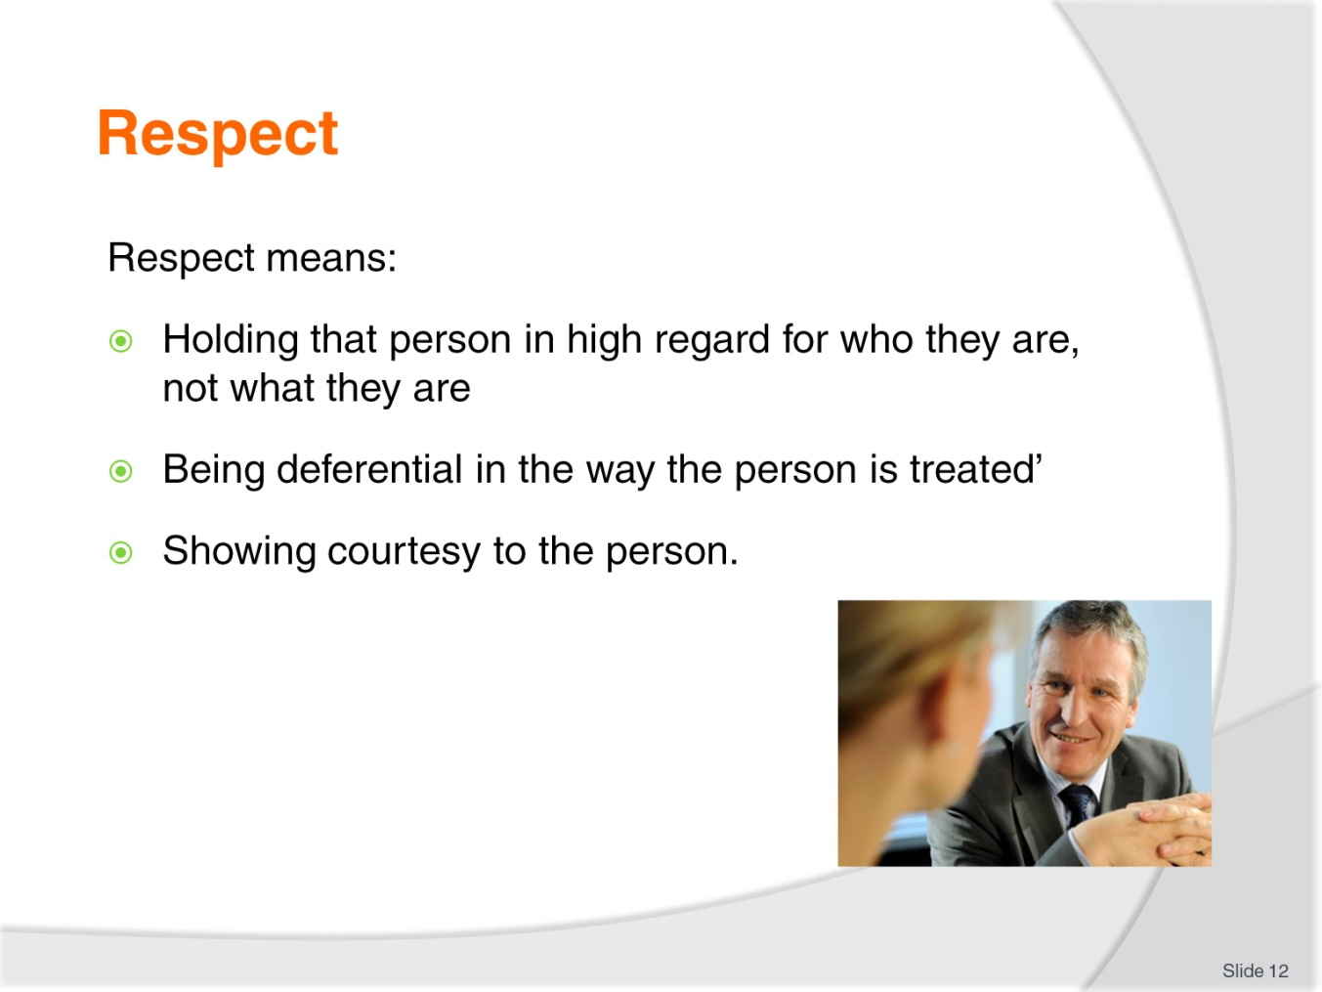
Slide No | Trainer Notes
Class Activity – General Discussion
What is respect?
How can you get the respect of others?
How do you show respect to someone else?

Slide
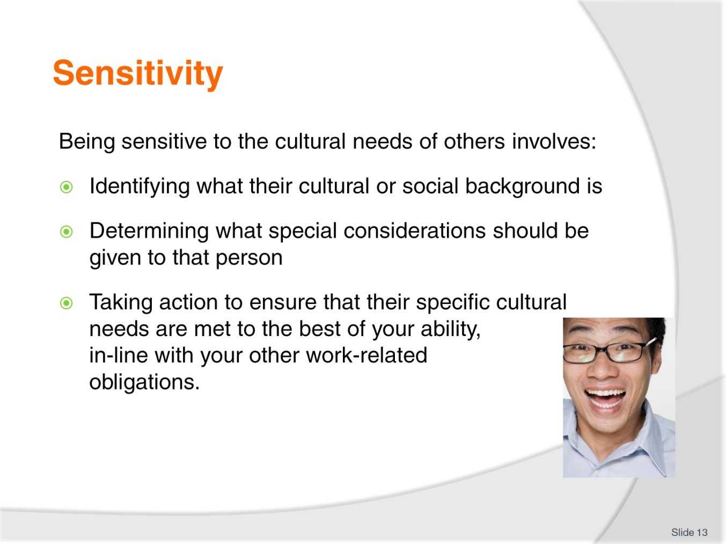
Slide No | Trainer Notes
Class Activity – General Discussion
What is sensitivity?
How do you show sensitivity to someone else?
What is harder to do – show respect or sensitivity?

Slide
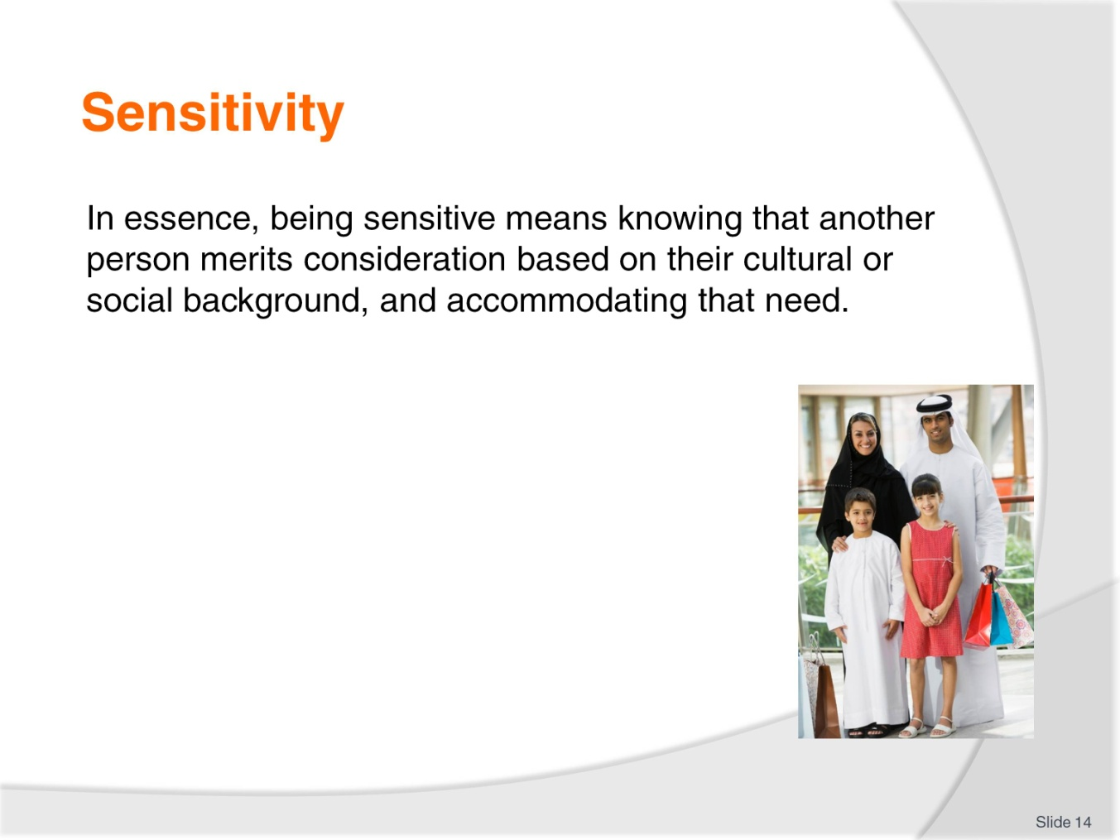
Slide No | Trainer Notes
Class Activity – General Discussion
Provide examples of where you have considered someone else and accommodated there need.

Slide
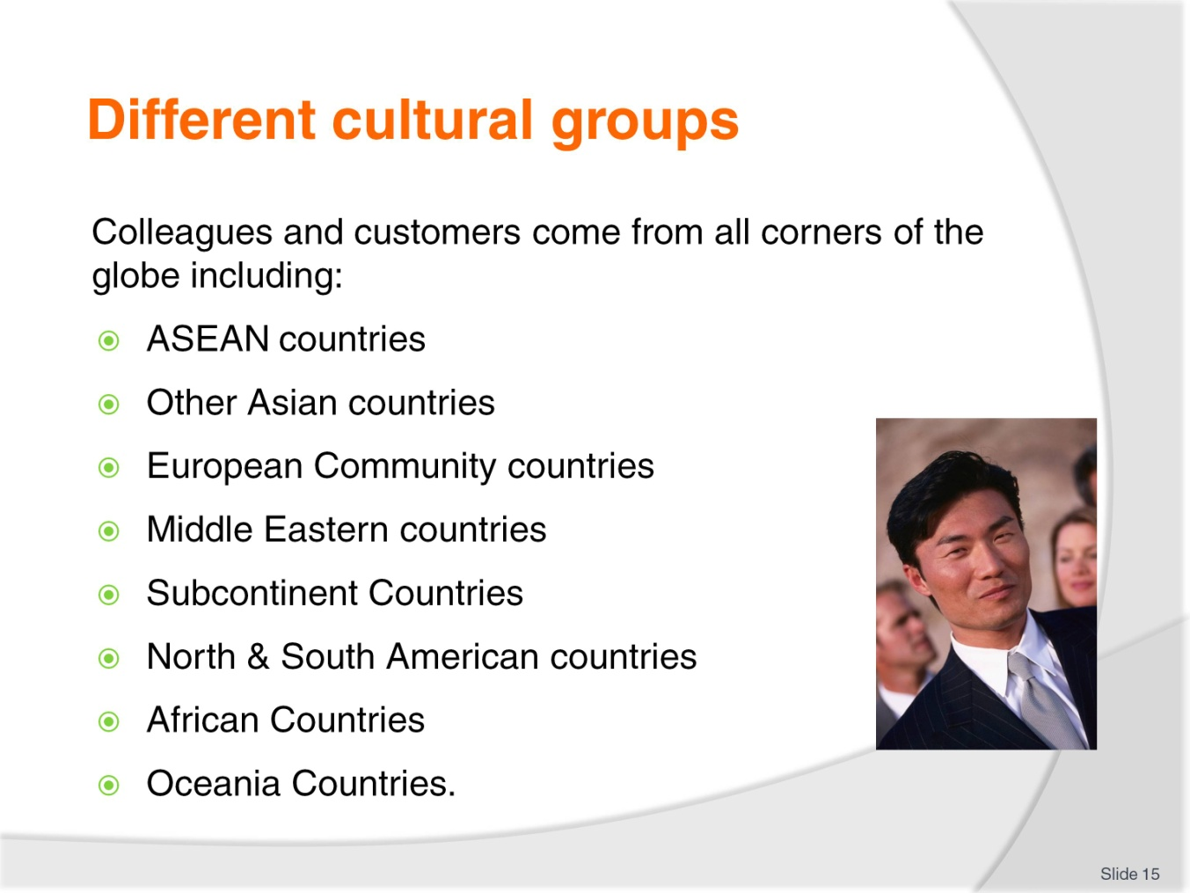
Slide No | Trainer Notes
Class Activity – List and discuss
Identify different countries located within the geographical areas listed in this slide
For each country identify some cultural characteristics and needs
Identify how a hospitality business can cater to these needs.

Slide
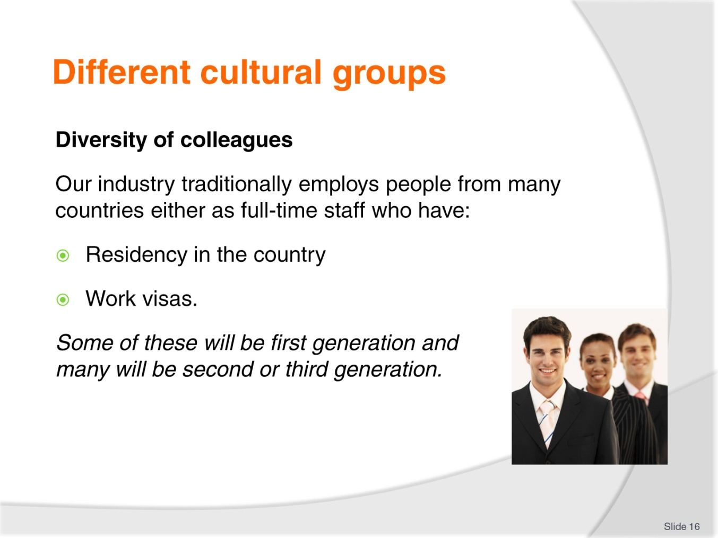
Slide No | Trainer Notes
Class Activity – Discussion
What different countries are staff in your organisation from?
Class Activity – General Discussion & Exercise (incorporates this and past slide)
Discuss the diversity of the audience in relation to these points. Write the answers down on the board.
You will find a great amount of diversity just amongst this group. Imagine the expanse of diversity given all the staff and customers in a typical hospitality business.
Given the list you have developed, what can a hospitality business do to help cater to these cultural differences?

Slide
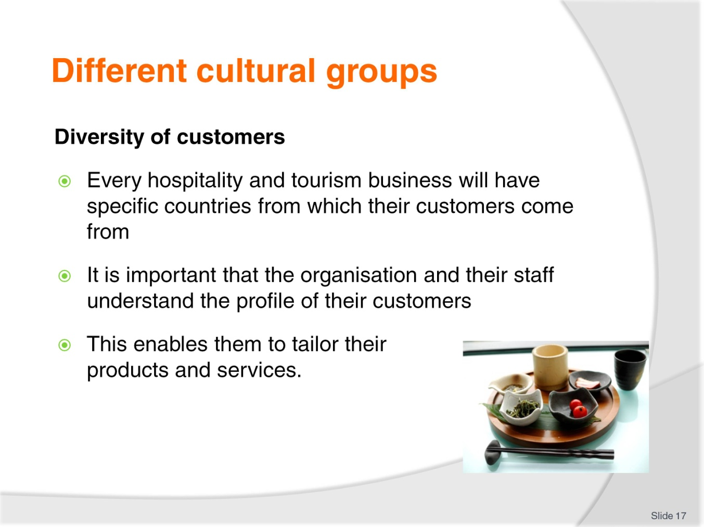
Slide No | Trainer Notes
Class Activity – Discussion
What different countries are customers coming to an organisation in your region from?
Why do they come to your region?
How can you tailor products and services to meet their needs?

Slide
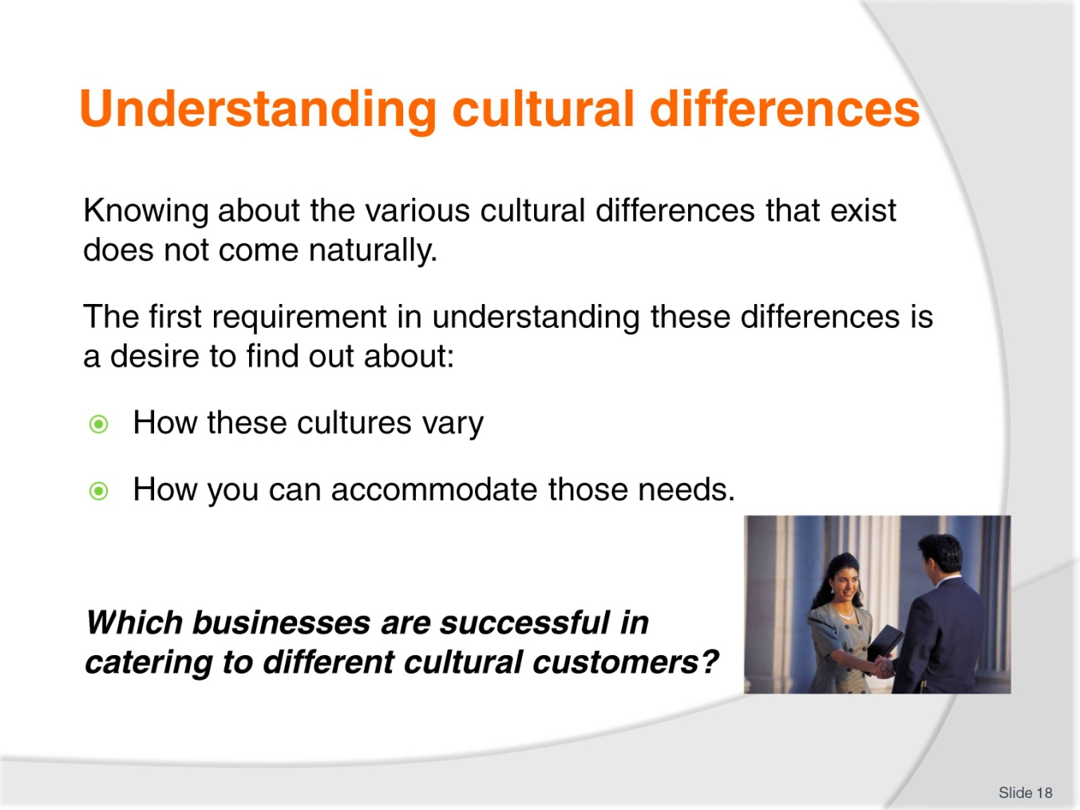
Slide No | Trainer Notes
Class Activity – Discussion
This slide contains the same topic as the previous slide.
You may wish to discuss businesses who have successfully catered to the needs of different cultural markets.

Slide
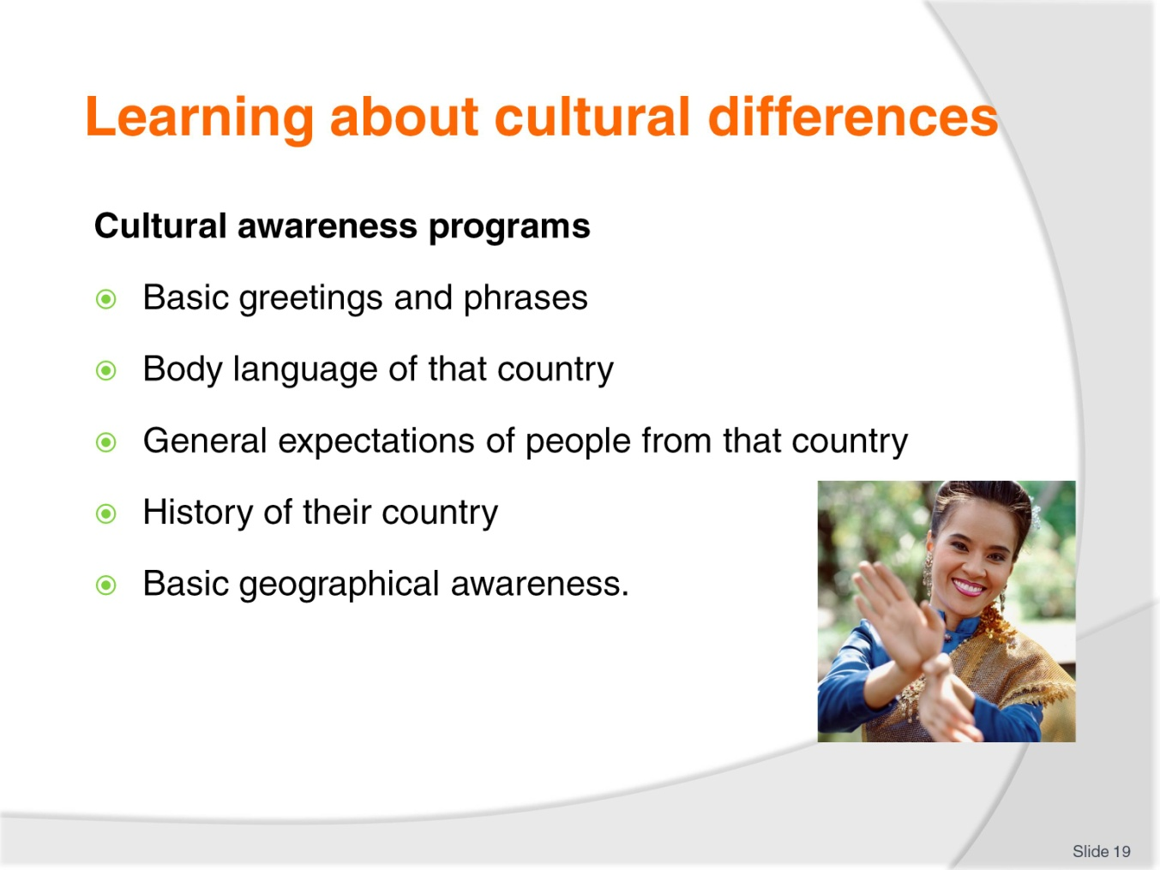
Slide No | Trainer Notes
Class Activity – Discussion
What are some examples of each point identified in this slide?

Slide
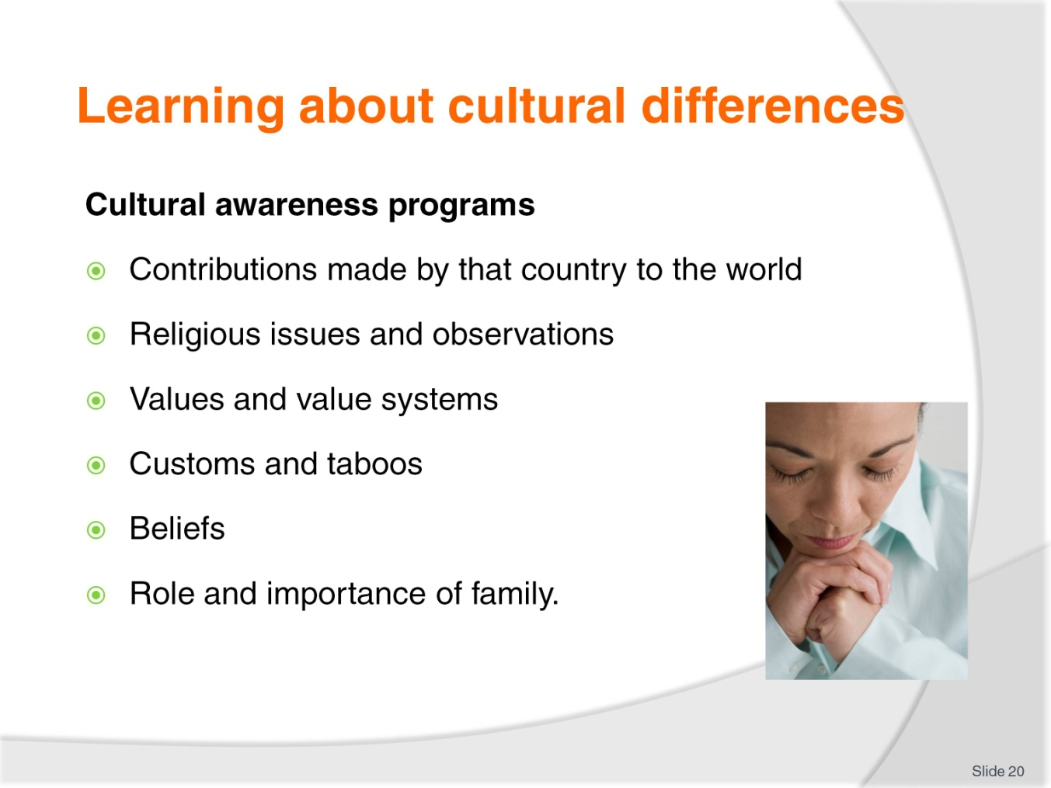
Slide No | Trainer Notes
Class Activity – Discussion
What are some examples of each point identified in this slide?

Slide
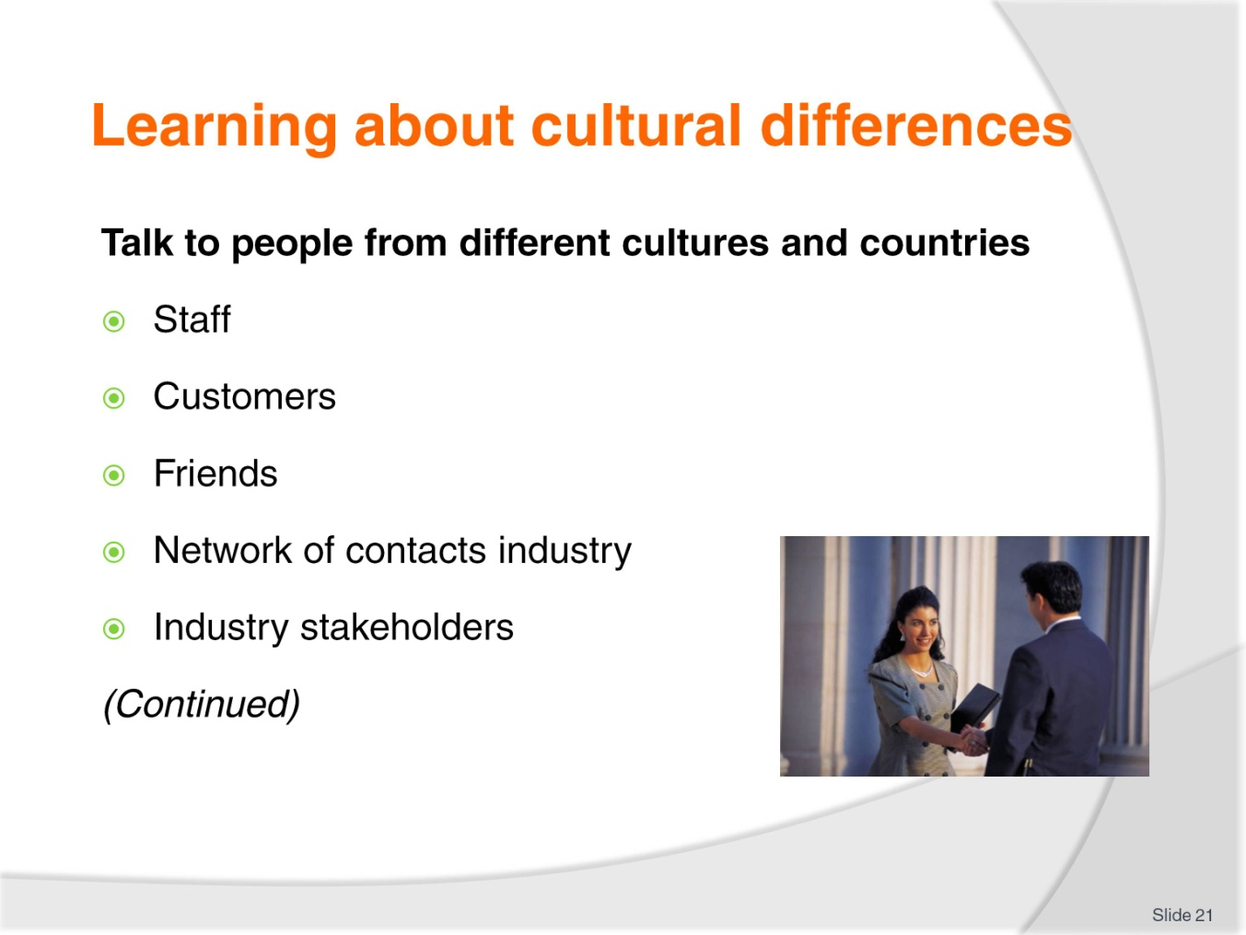
Slide No | Trainer Notes
Class Activity – Discussion
What are some examples of each point identified in this slide?
What can you learn from them?

Slide
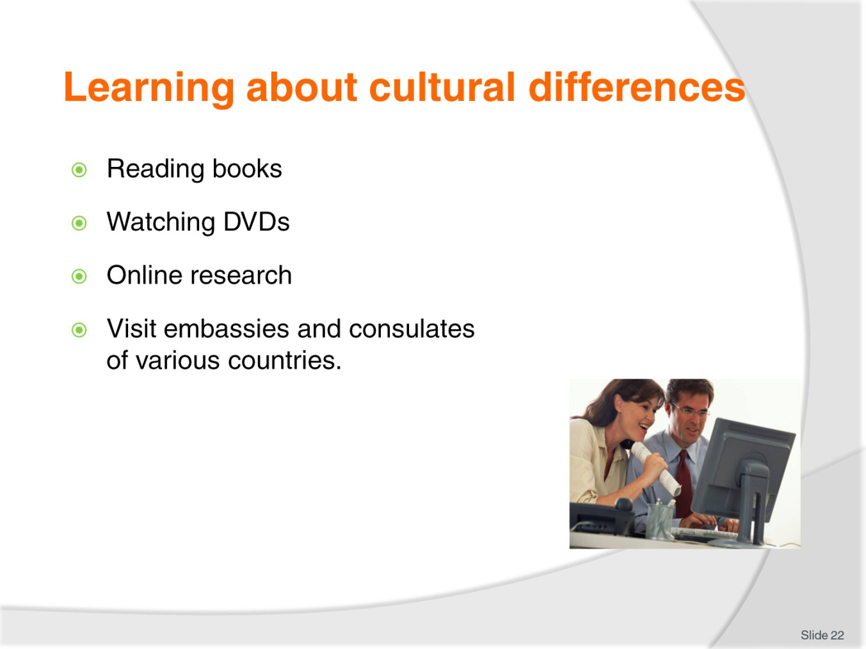
Slide No | Trainer Notes
Class Activity – Discussion
What are good websites you would look up?
What are some examples of each point identified in this slide?
What can you learn from them?

Slide
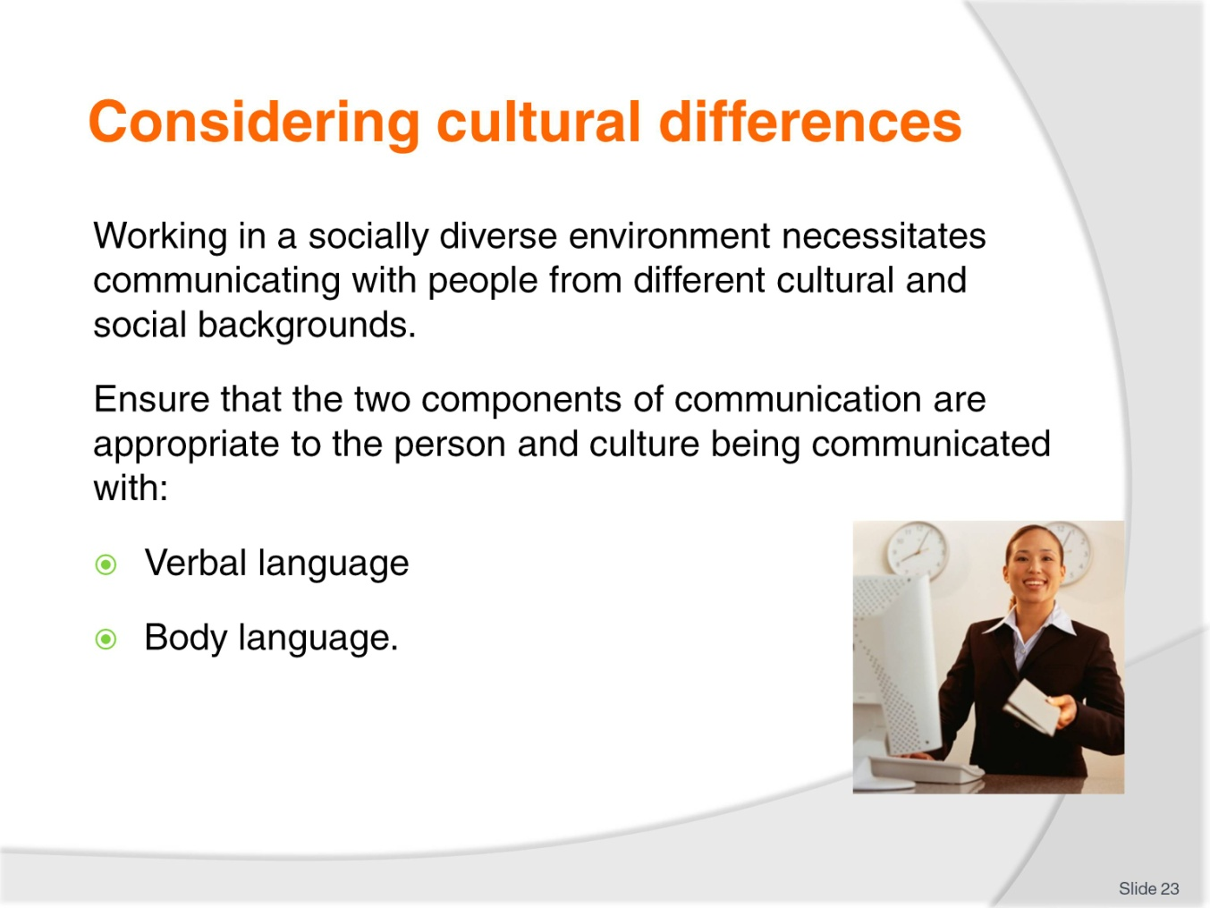
Slide No | Trainer Notes
Class Activity – Discussion
How do you use verbal language to communicate?
How do you use body language to communicate?

Slide
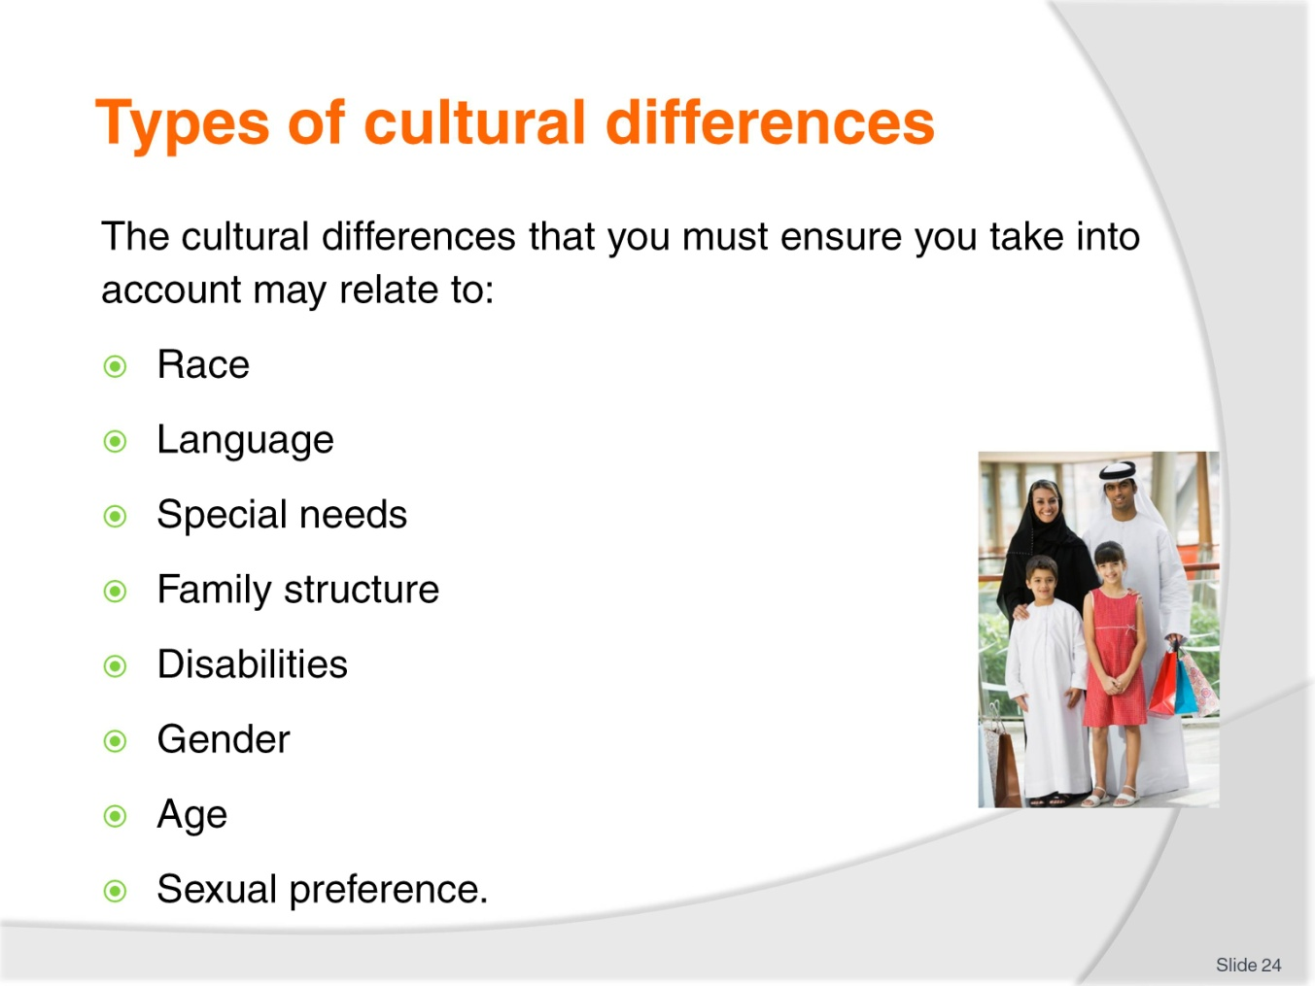
Slide No | Trainer Notes
Class Activity – Group Exercise
Break the audience into groups and give each group one point identified in this slide.
For each of the points identified in this slide:
- Provide examples
- Provide how these differences may cause problems
- Identify ways a hospitality organisation can accommodate these cultural differences – considering products and services.

Slide
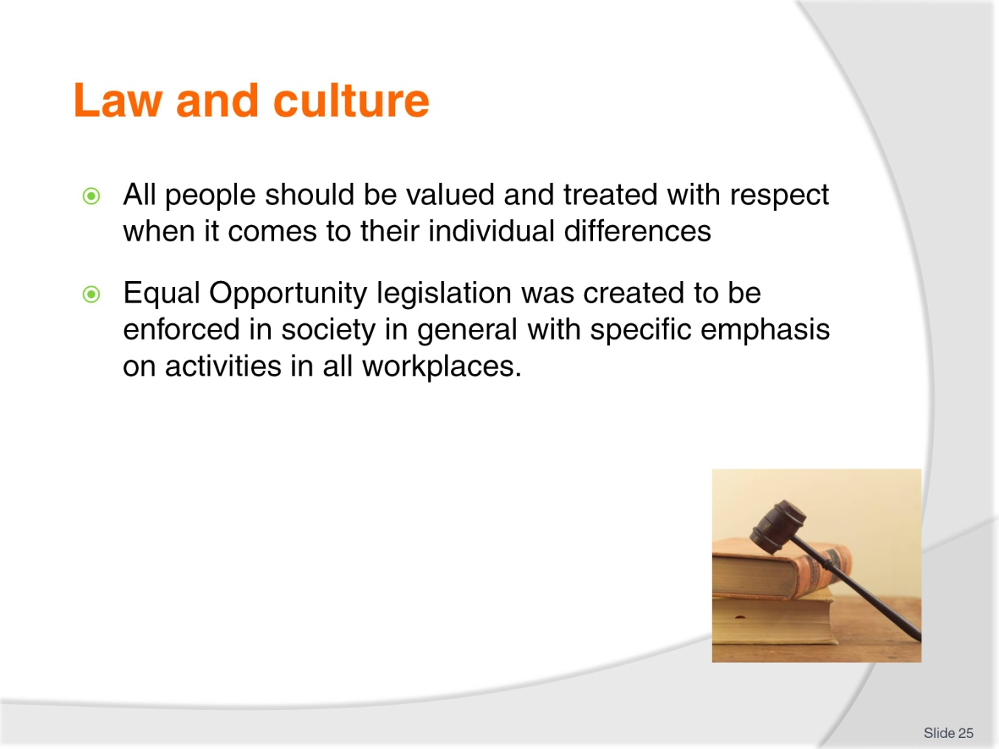
Slide No | Trainer Notes
Class Activity – Research and discuss
The class should research specific equal opportunity legislation and/or employment law as applied to your country:
What specific laws exist to provide equality in the work place?
What areas or topics do these laws cover?

Slide
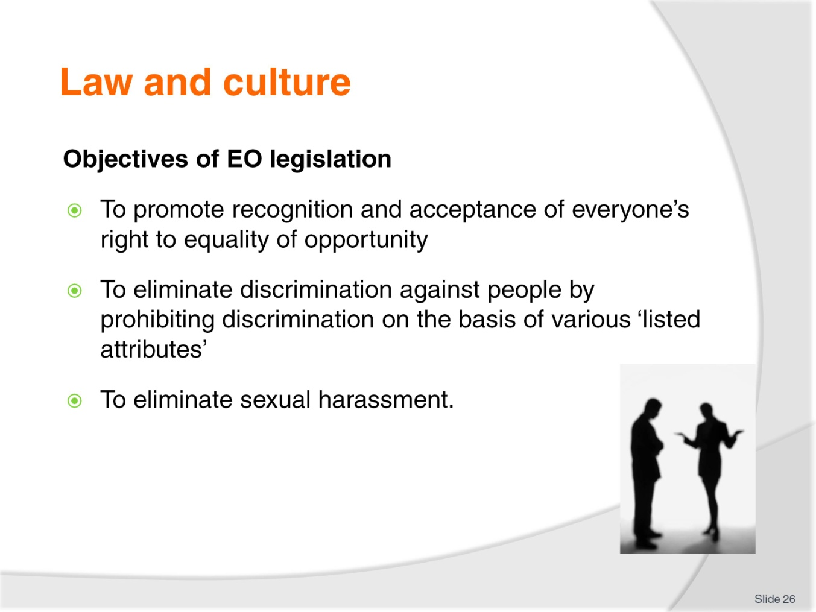
Slide No | Trainer Notes
Class Activity – Discussion
Based on your research in the past slide:
Do these generic objectives differ in your country?
What are the differences and why do they exist?

Slide
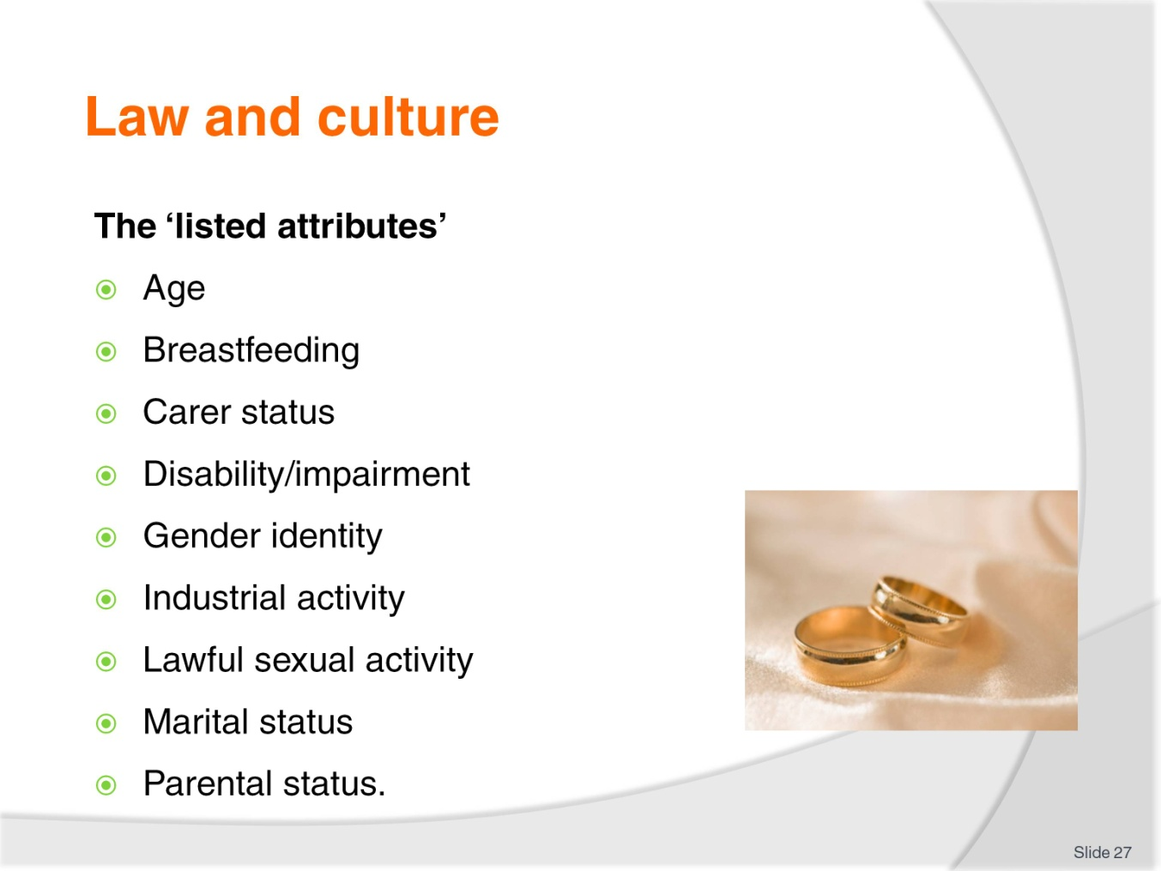
Slide No | Trainer Notes
Class Activity – Discussion
Based on your research in the past slides:
Are there specific legal requirements for each of these points that apply in a hospitality business?

Slide
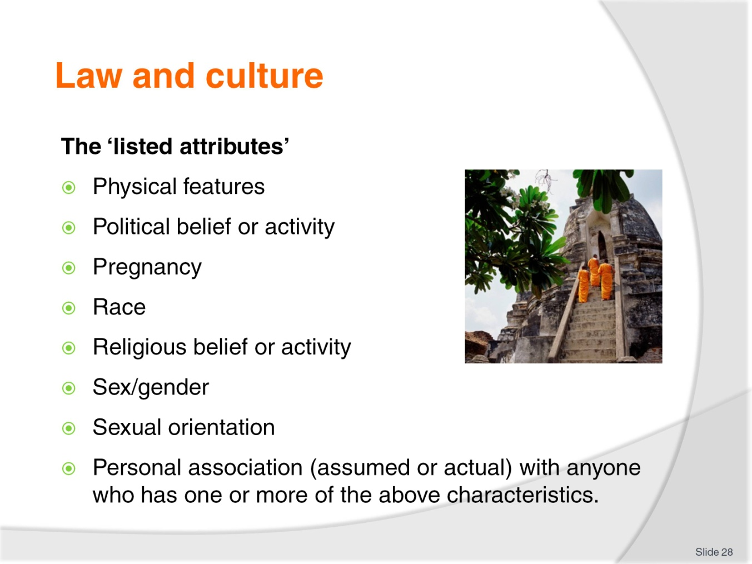
Slide No | Trainer Notes
Class Activity – Discussion
Based on your research in the past slides:
Are there specific legal requirements for each of these points that apply in a hospitality business?

Slide
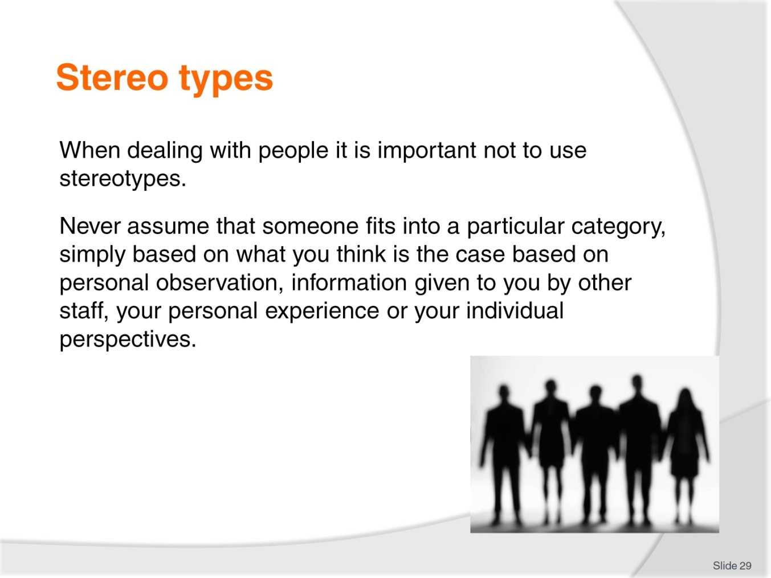
Slide No | Trainer Notes
Class Activity – Discussion
What are common stereo types that exist?
Identify different countries and think of generic stereotypes we may have about people from them?
How true are these stereotypes?
What stereotypes does the rest of the world have about people from your country?
How true are these stereotypes?

Slide
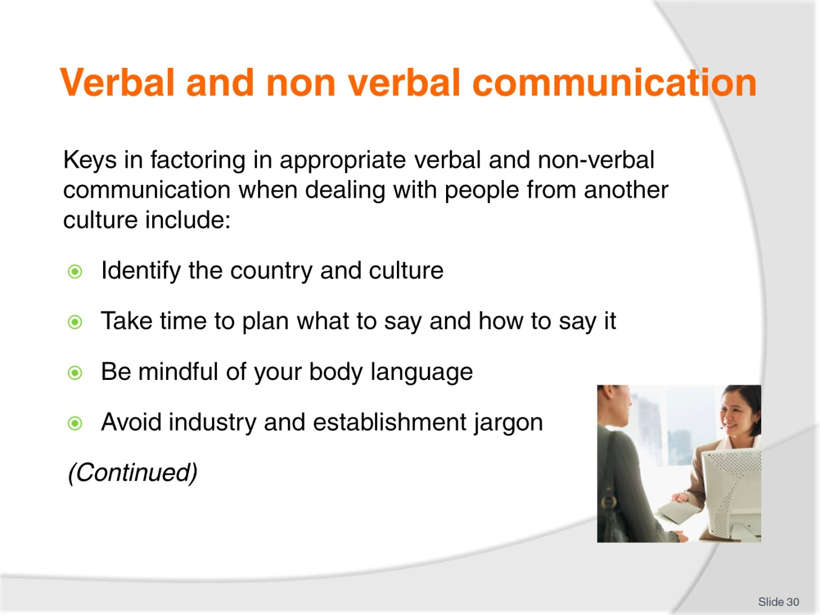
Slide No | Trainer Notes
Class Activity – Discussion
Provide examples for each point in this slide and how they can easily cause communication problems
Provide examples of how these can be applied correctly for effective communication.

Slide
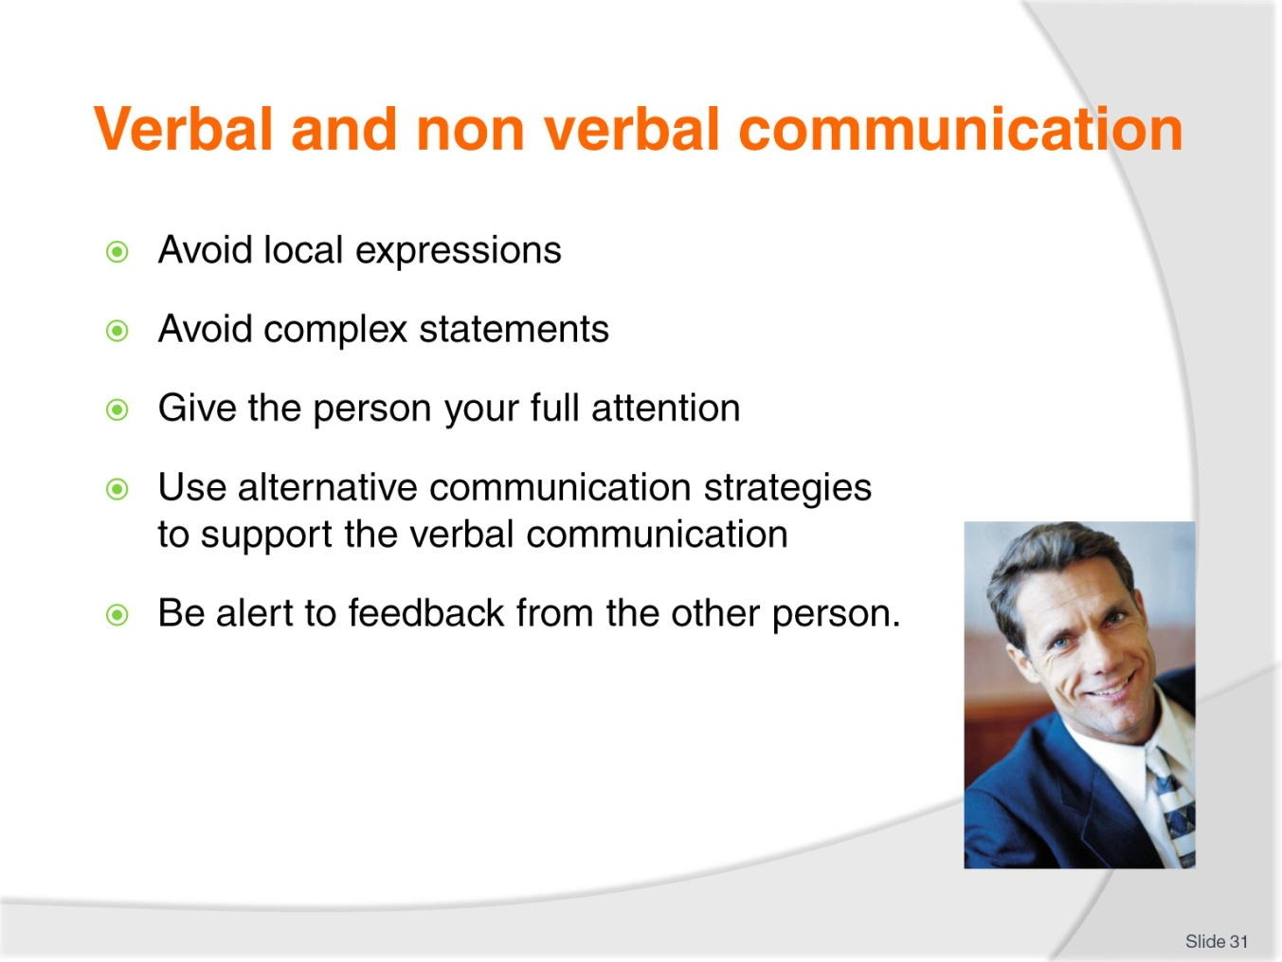
Slide No | Trainer Notes
Class Activity – Discussion
Provide examples for each point in this slide and how they can easily cause communication problems
Provide examples of how these can be applied correctly for effective communication.

Slide
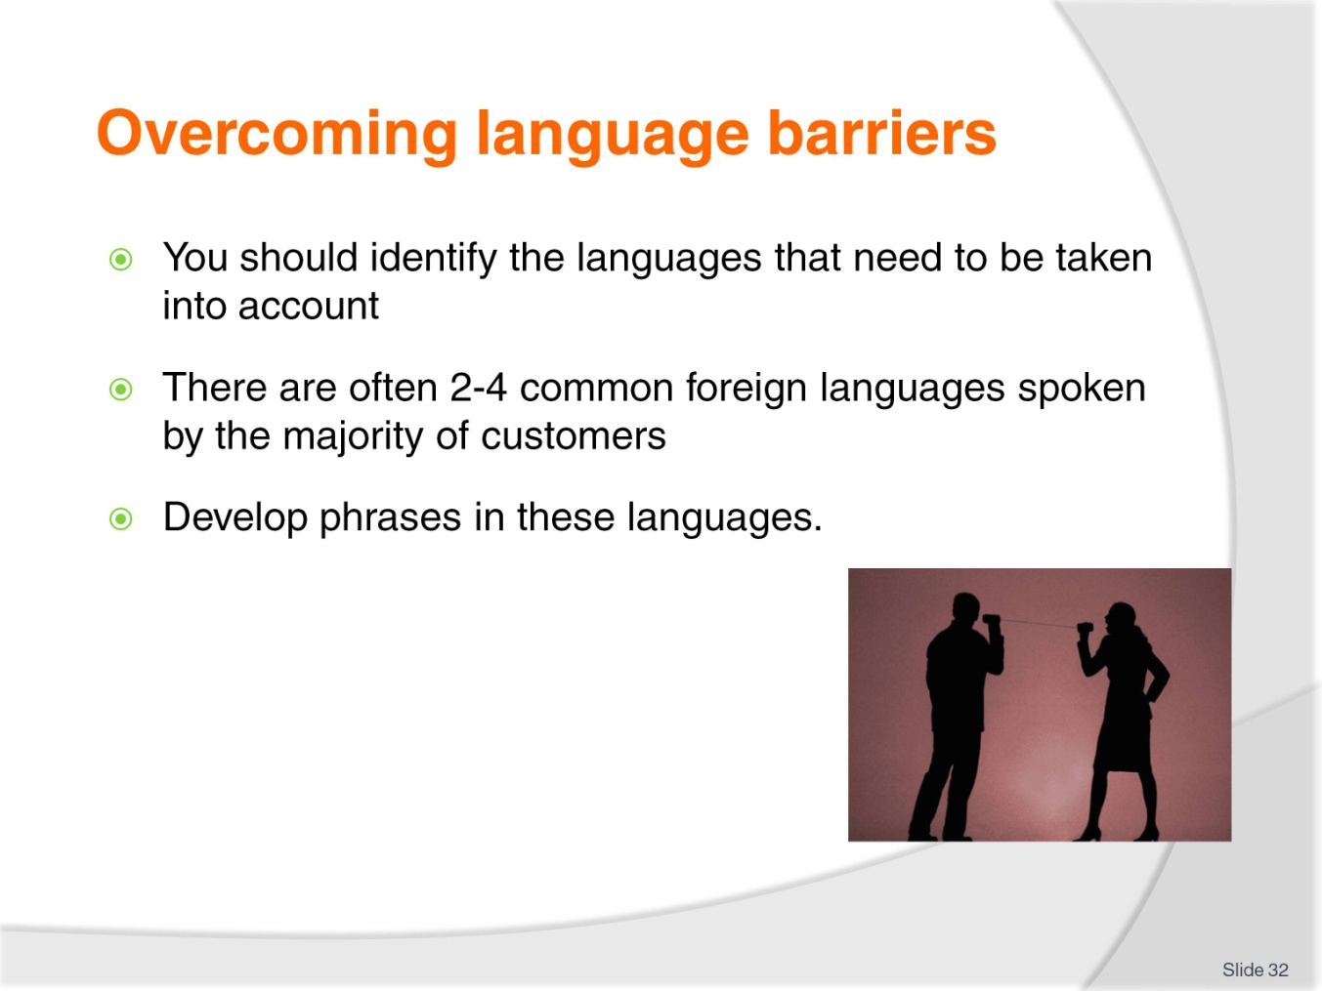
Slide No | Trainer Notes
Class Activity – Discussion
What are the common foreign languages used by the majority of customers in your country? Select a maximum of 4 languages
What are some phrases that would be useful to know?
Class Activity – Language Phrases
Research, identify and practice some of the phrases in small groups. You may want to write them on pieces of paper with the foreign phrase on one side and your language on the other. Read out the phrase and see if the audience can a) identify the language b) identify the phrase.

Slide
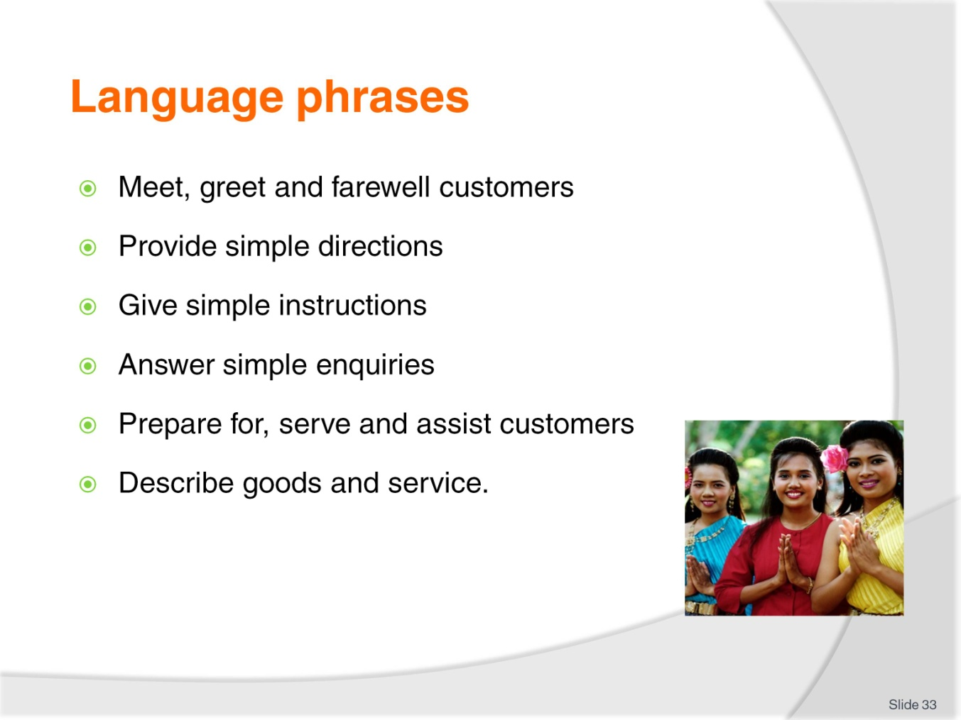
Slide No | Trainer Notes
Meet, greet and farewell customers – at different times of the day, and to different types of customers including men, women, children and business people.
Provide simple directions – to the restaurant, bar, swimming pool, different floors, various rooms as well as to common landmarks and tourist attractions.
Give simple instructions – on how to use telephones, how to operate in-room and venue facilities.
Answer simple enquiries – such as questions relating to availability of rooms, process of goods and services and local conditions.
Prepare for, serve and assist customers – in accordance with your designated work role and responsibilities. For instance, the language needs of a front office receptionist will differ to those of a room attendant which will be, in turn, different to those required by a food and beverage waiter or a bar attendant.
Describe goods and service – once again this will relate to your specific workplace role. For example, a food waiter should be able to describe tastes, smells, ingredients, cooking styles, portion sizes and so on.
Class Activity – Discussion
Explain the information you would like to communicate within the points mentioned in the slide.

Slide
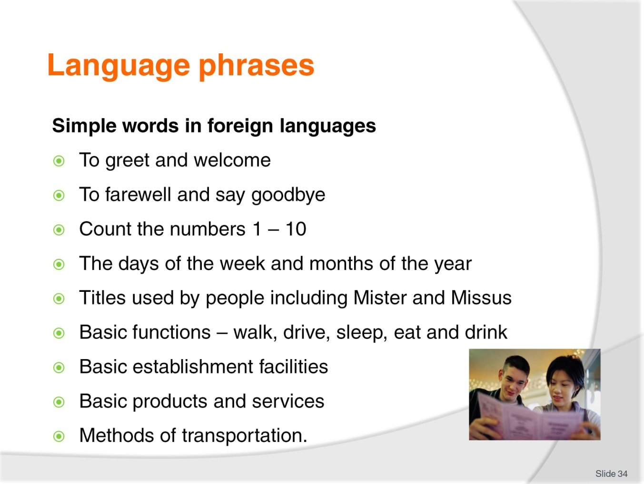
Slide No | Trainer Notes
Class Activity – Discussion
Identify phrases you would like to communicate for each of the points mentioned in the slide.

Slide
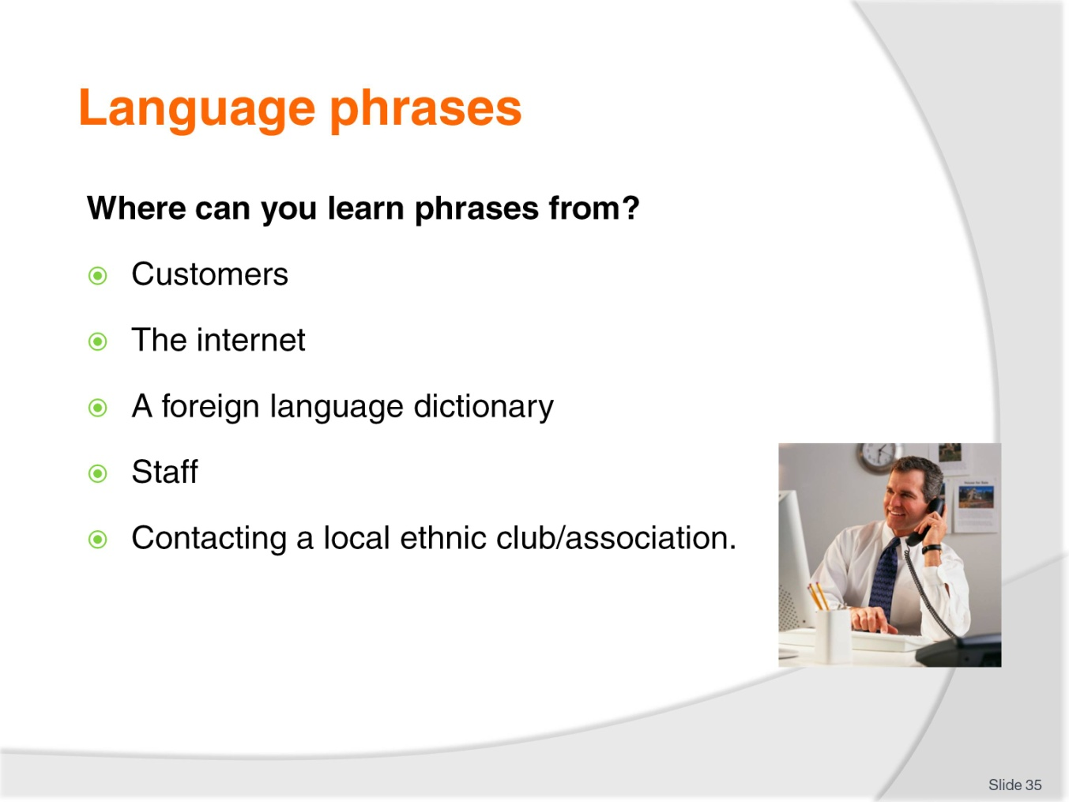
Slide No | Trainer Notes
Class Activity – Discussion
What could you learn from each source?
What are good internet websites to use?

Slide
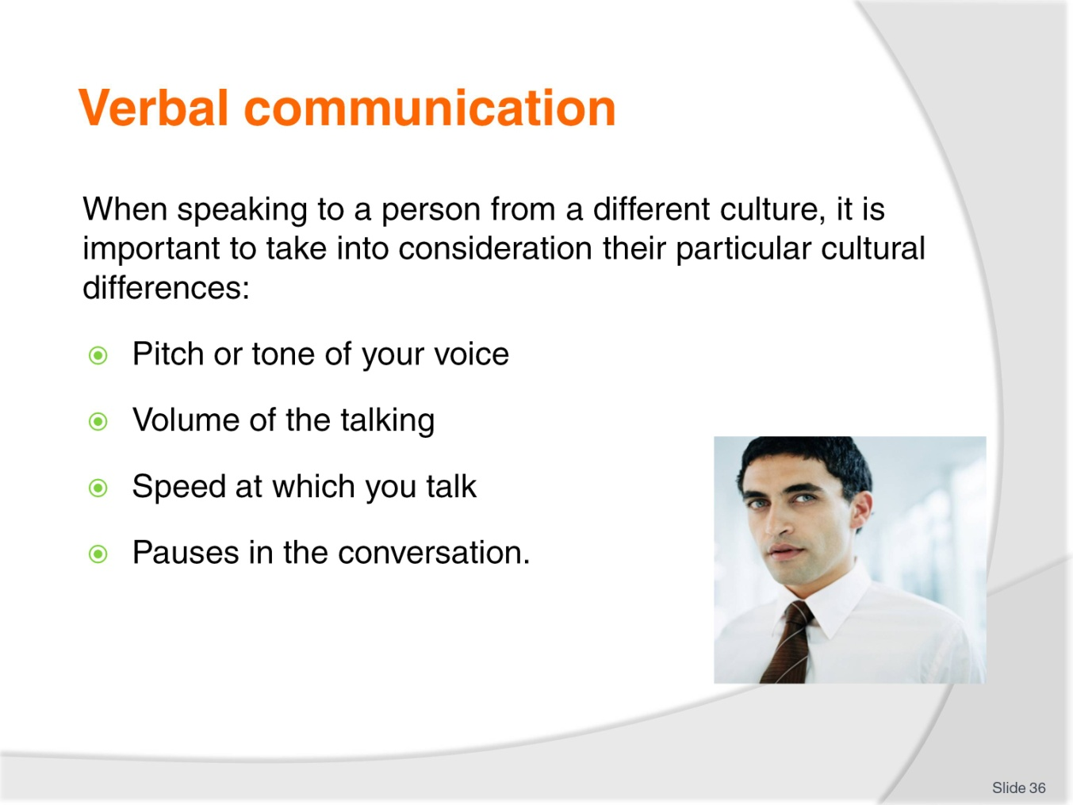
Slide No | Trainer Notes
Class Activity – Discussion
For each of the points mentioned in the slide, what techniques could you use to make your verbal communication effective?

Slide
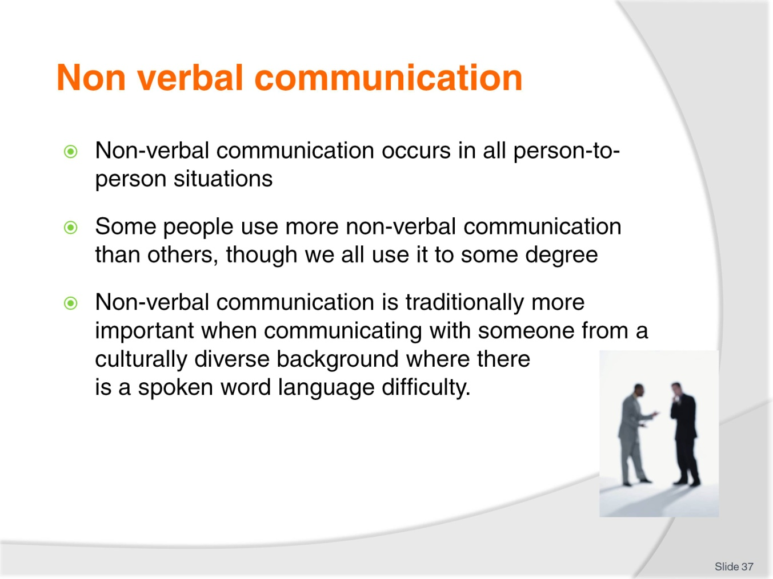
Slide No | Trainer Notes
Class Activity – Discussion
How can you use non-verbal communication to actually communicate?

Slide
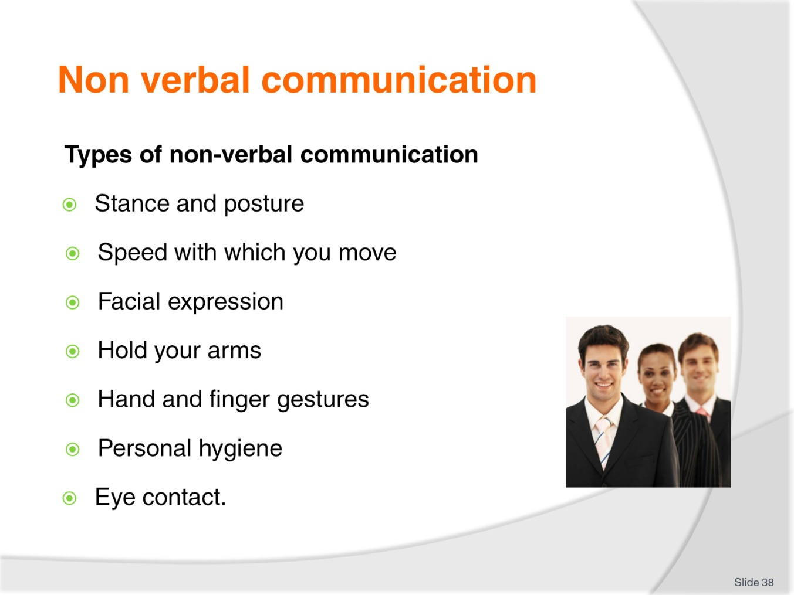
Slide No | Trainer Notes
Class Activity – Discussion
What do each of these types of non-verbal communication communicate?
See below for examples.
Your stance and posture may be interpreted as:
Shoulders back – positive attitude
Shoulders slumped forward – negative attitude.
The speed with which you move may be interpreted as:
Slow walk – don’t care
Fast walk – flat out and stressed.
Your facial expression may be interpreted as:
Grumpy face – don’t want to be at work; don’t like the person they are talking to
Smiling face – happy with life; happy to work with customers.
How you hold your arms may be interpreted as:
Arms crossed – defensive
Arms at your side – open to discussion.
Hand and finger gestures may be interpreted as:
Waving a hand – saying goodbye
Curling a finger - beckoning
The thumbs up – all is okay or some other more abusive message!
How you attend to your personal hygiene may be interpreted as:
Bad body odour – don’t care attitude; disrespect for others
Hair tied back neatly – person with pride; respect for others.
Eye contact may be interpreted as:
Direct eye contact – telling the truth, intimidating, sexual
No eye contact – not listening, disinterested or lying.

Slide
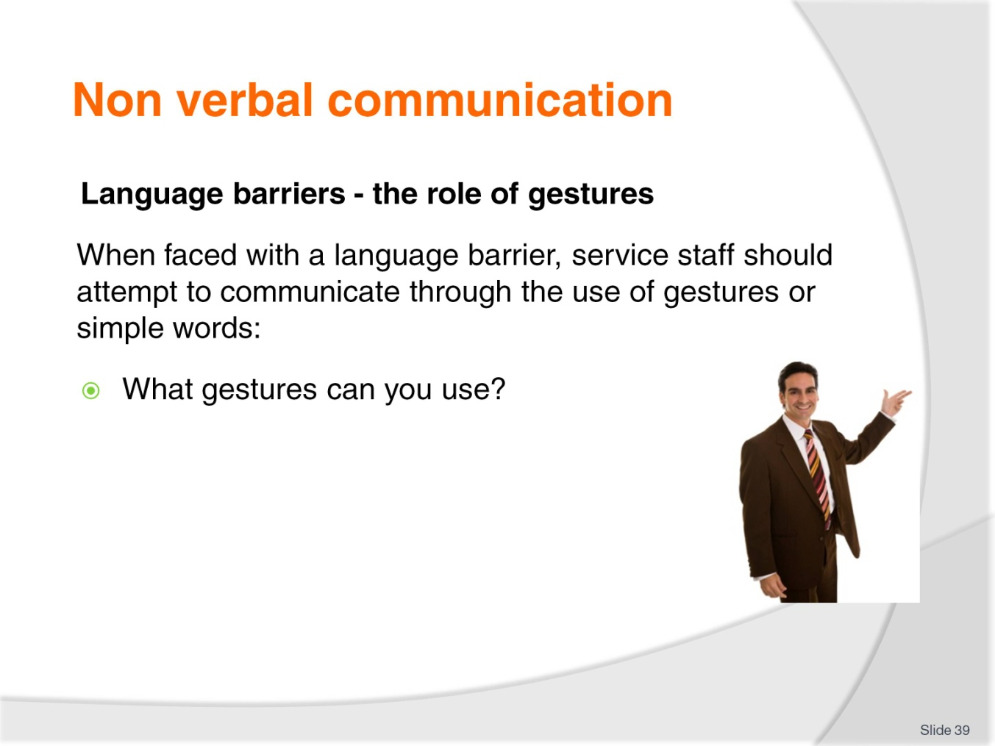
Slide No | Trainer Notes
Class Activity – Charades
Get the audience to play charades. Get them to communicate just using gestures.

Slide
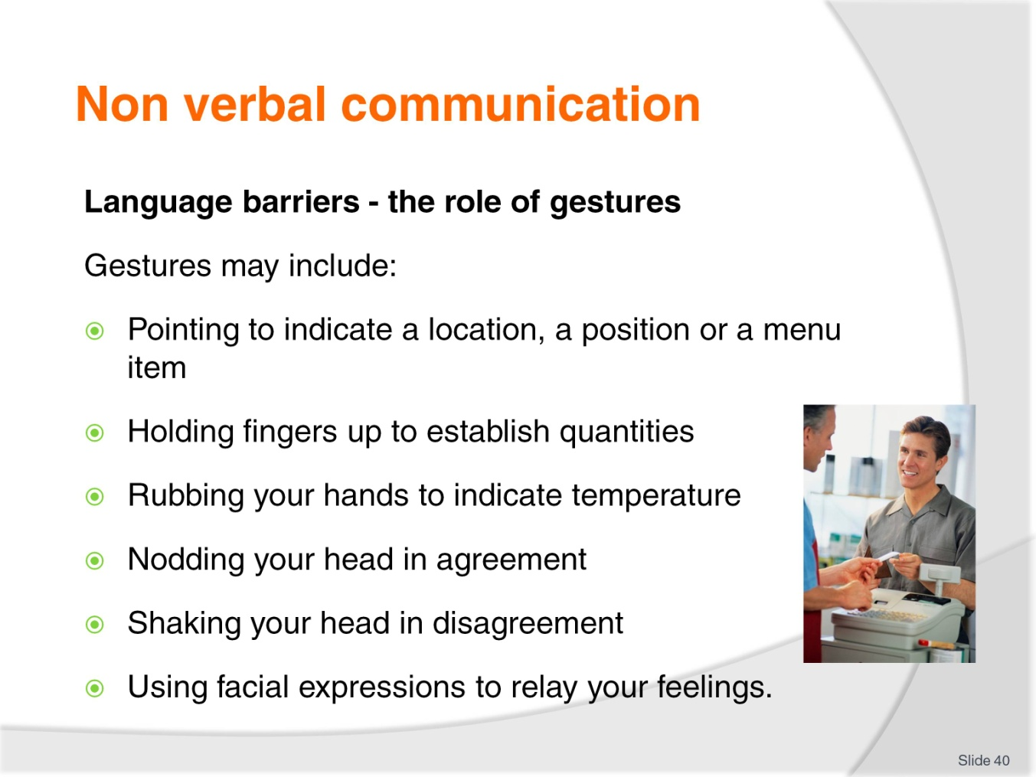
Slide No | Trainer Notes
Class Activity – Discussion
Discuss points.

Slide
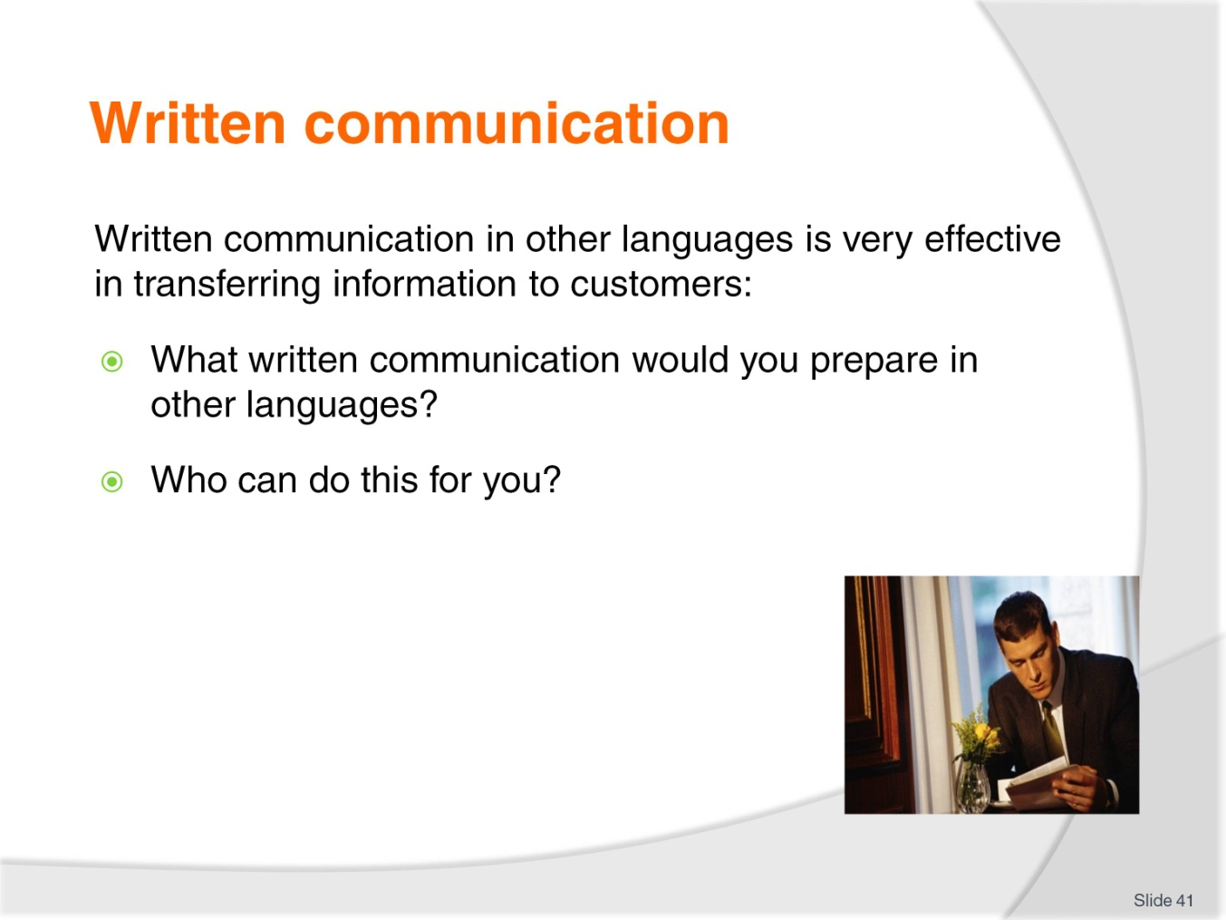
Slide No | Trainer Notes
Class Activity – Discussion
Discuss questions in the slide.

Slide
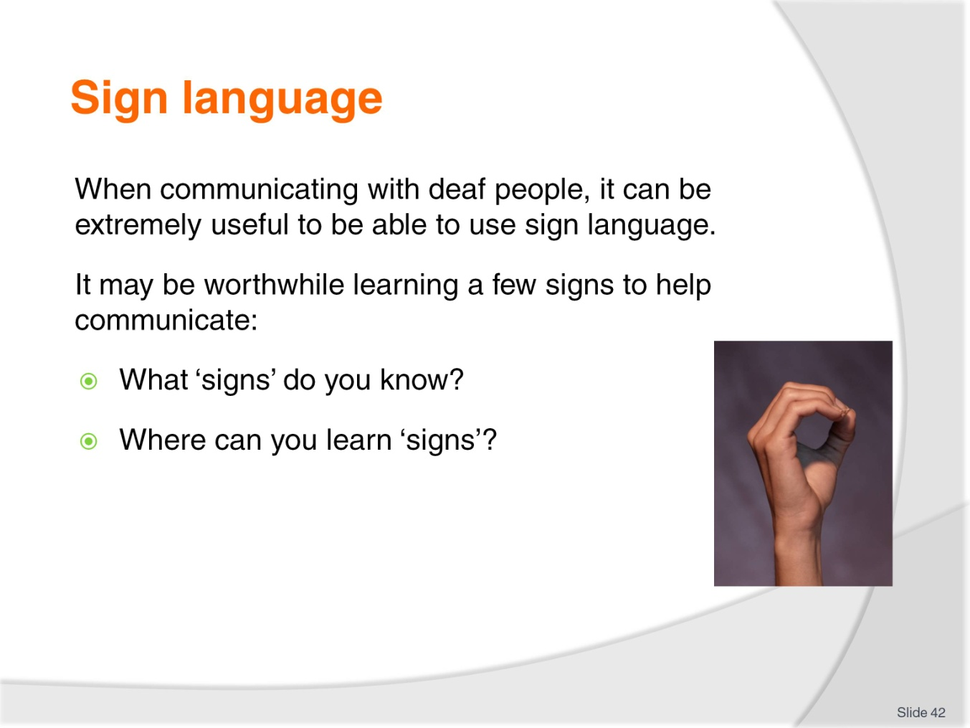
Slide No | Trainer Notes
Class Activity – Discussion
Discuss questions in the slide.

Slide
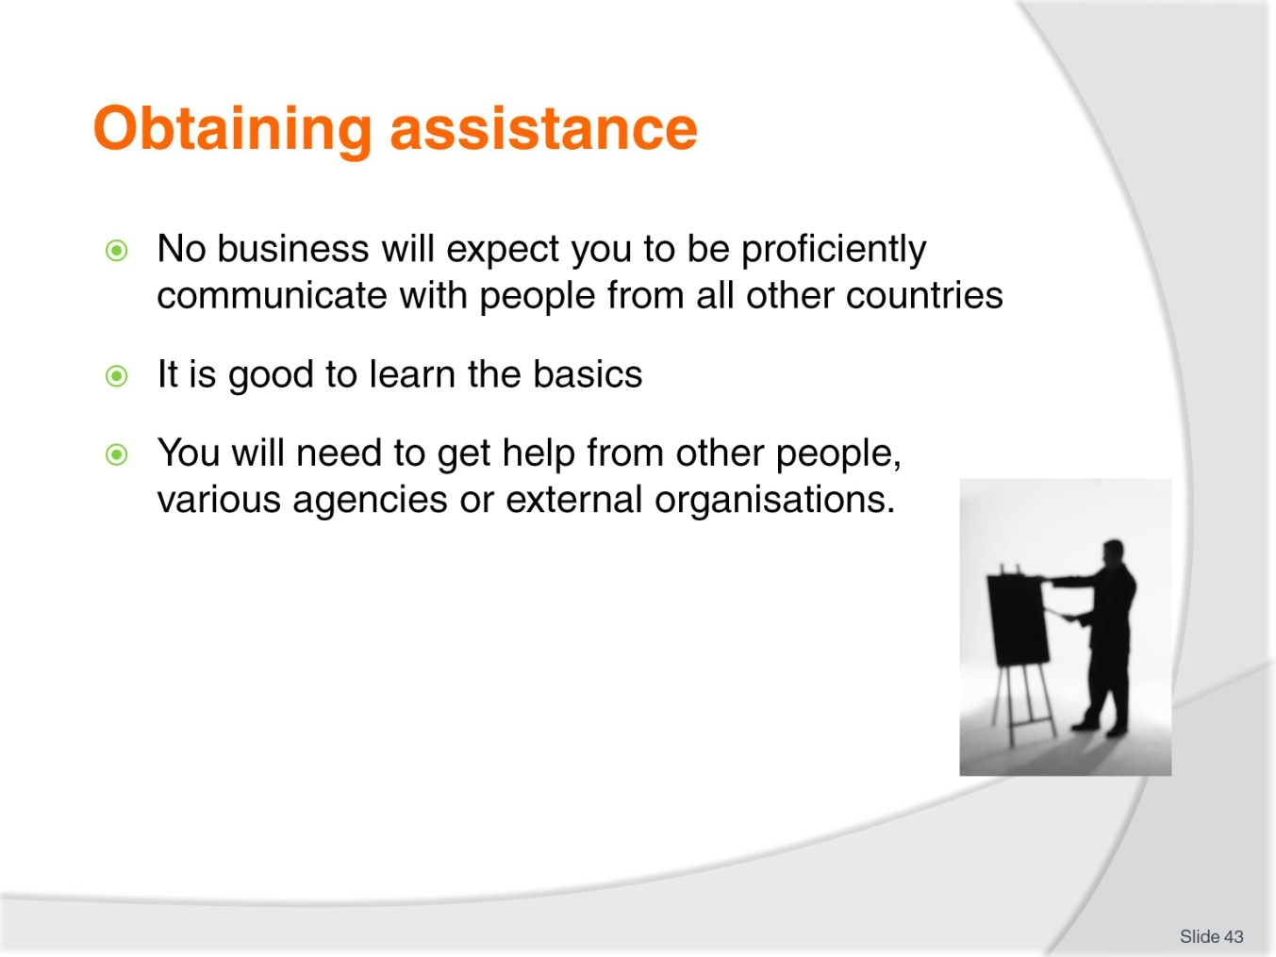
Slide No | Trainer Notes
Class Activity – Discussion
Where can you get help, both inside and outside of the business?

Slide
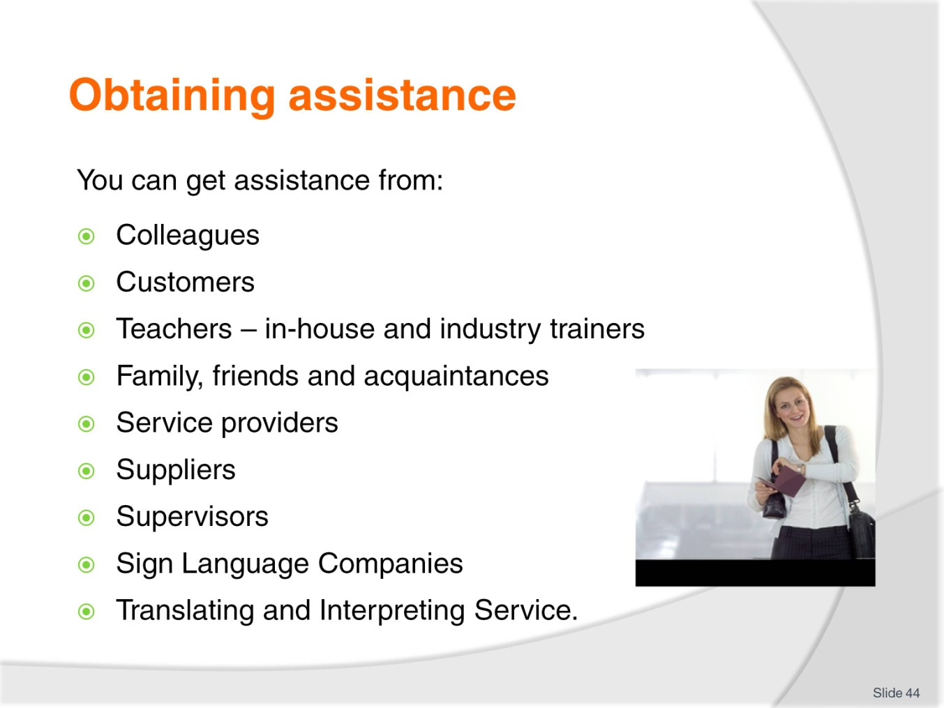
Slide No | Trainer Notes
Class Activity – Discussion
What assistance can you get from each person identified in the slide?

Slide
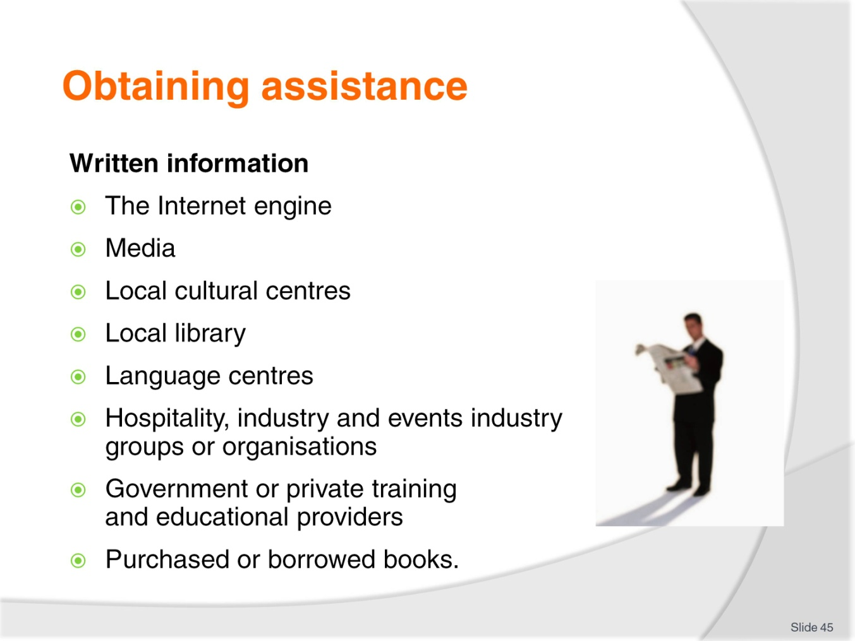
Slide No | Trainer Notes
Class Activity – Discussion
What assistance can you get from each person identified in the slide?

Slide
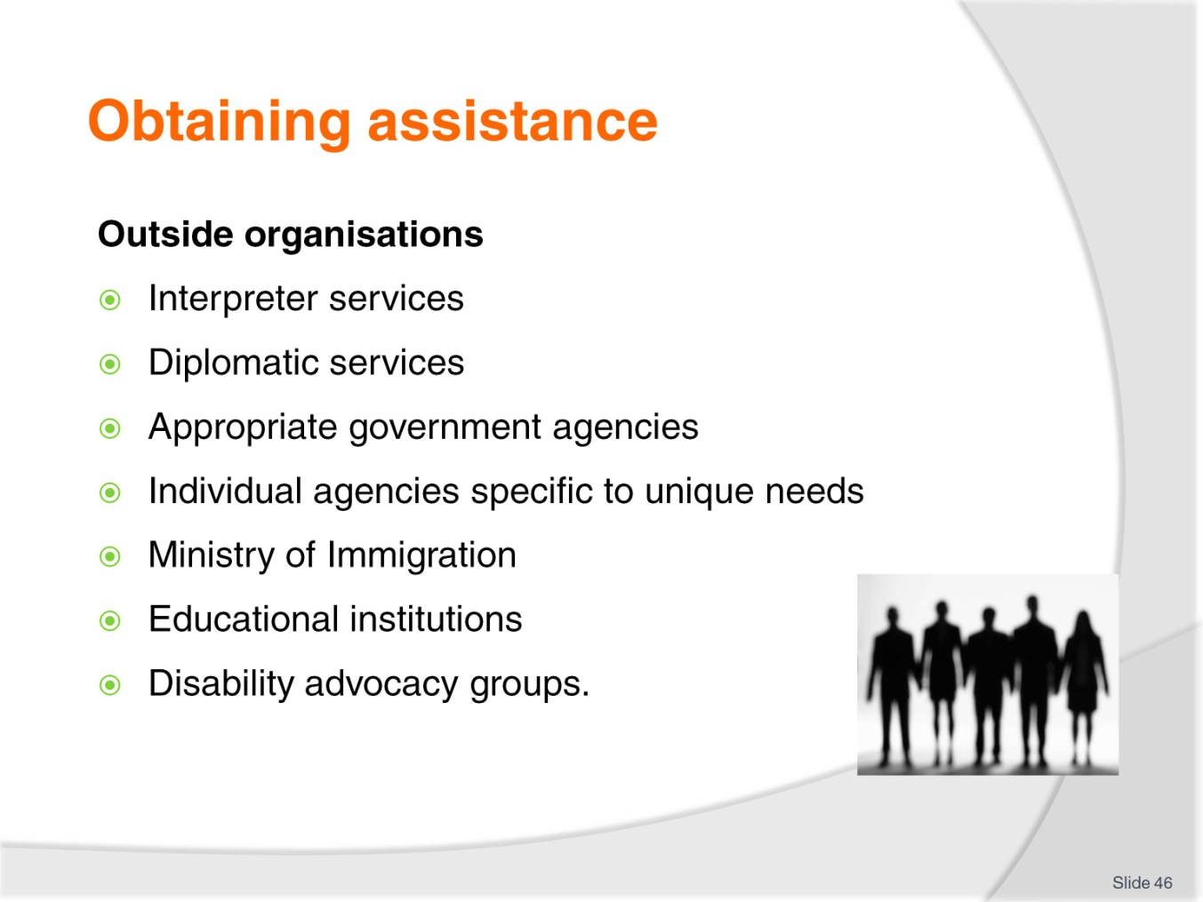
Slide No | Trainer Notes
Class Activity – Discussion
What assistance can you get from each person identified in the slide?

Slide
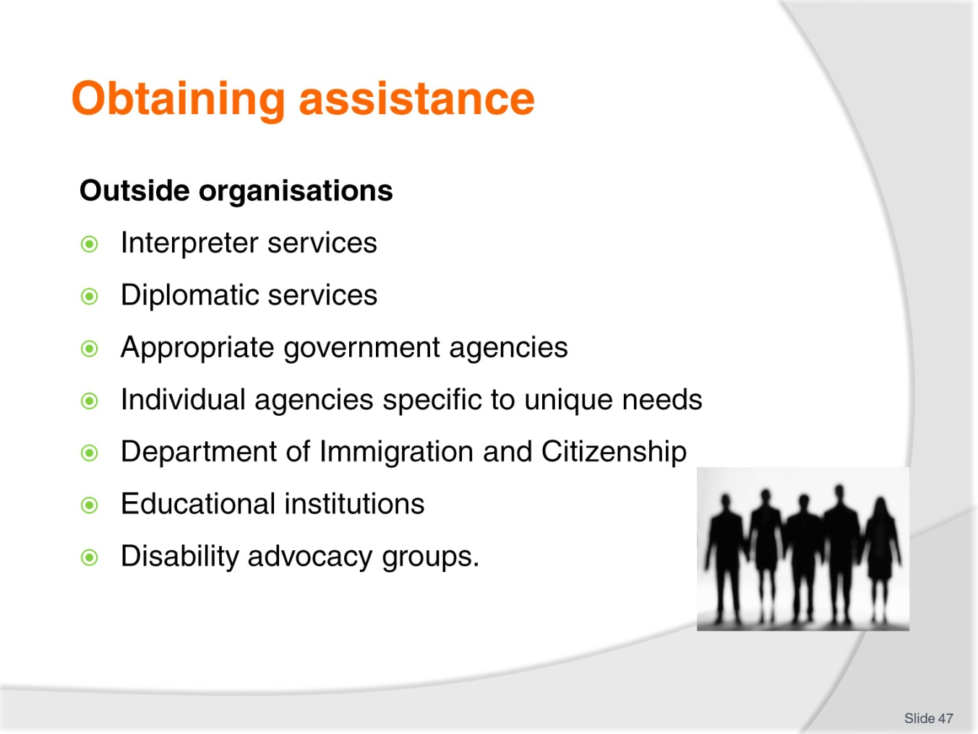
Slide No | Trainer Notes
Class Activity – Discussion
What assistance can you get from each person identified in the slide?

Slide
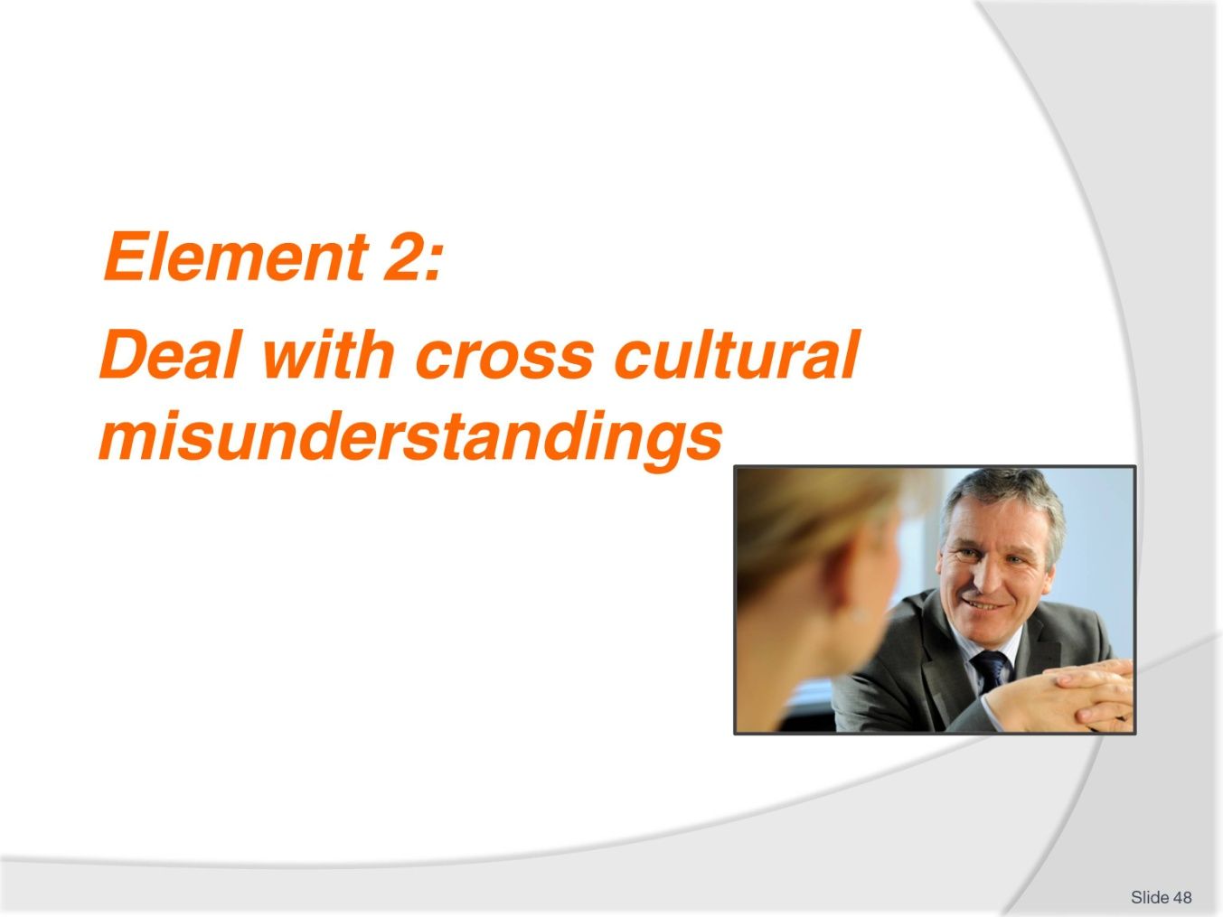
Slide No | Trainer Notes
Introduce topic
Class Activity – General Discussion
Ask general questions:
What is a misunderstanding?
What are common cross cultural misunderstandings?
What are they caused by?
How can they be avoided?

Slide
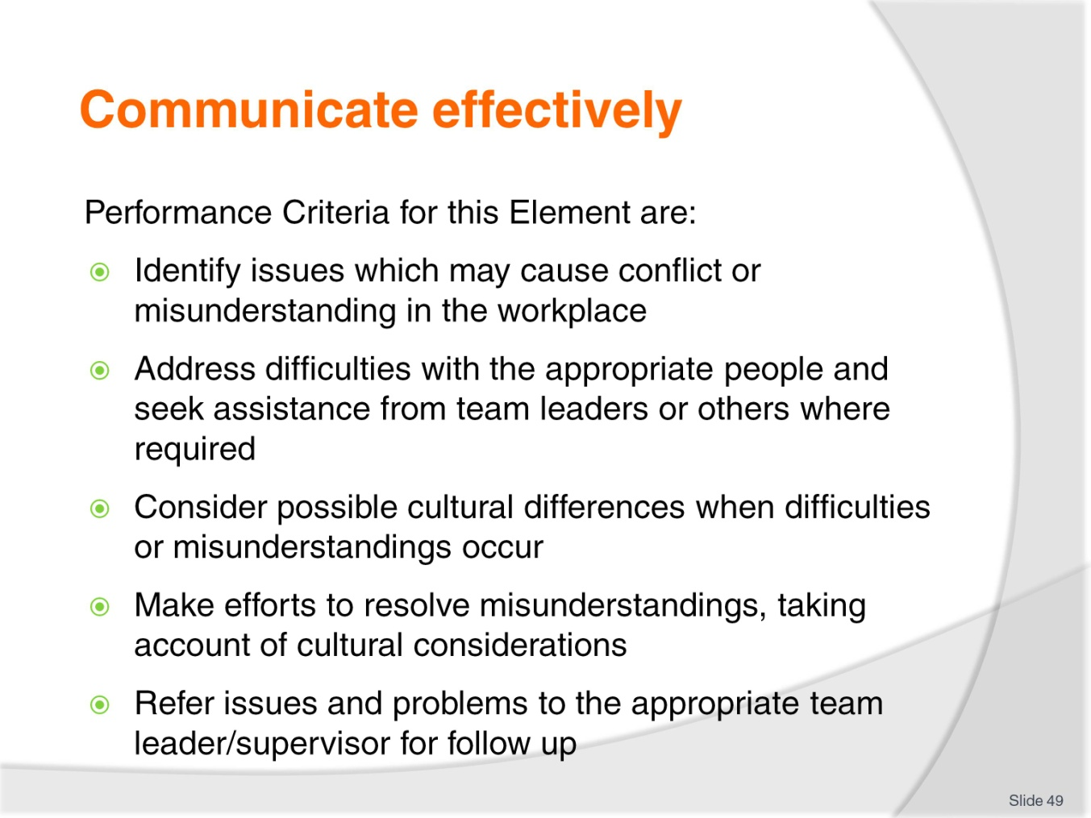
Slide No | Trainer Notes
 | Trainer identifies the Performance Criteria for this Element, as listed on the slide.

Slide
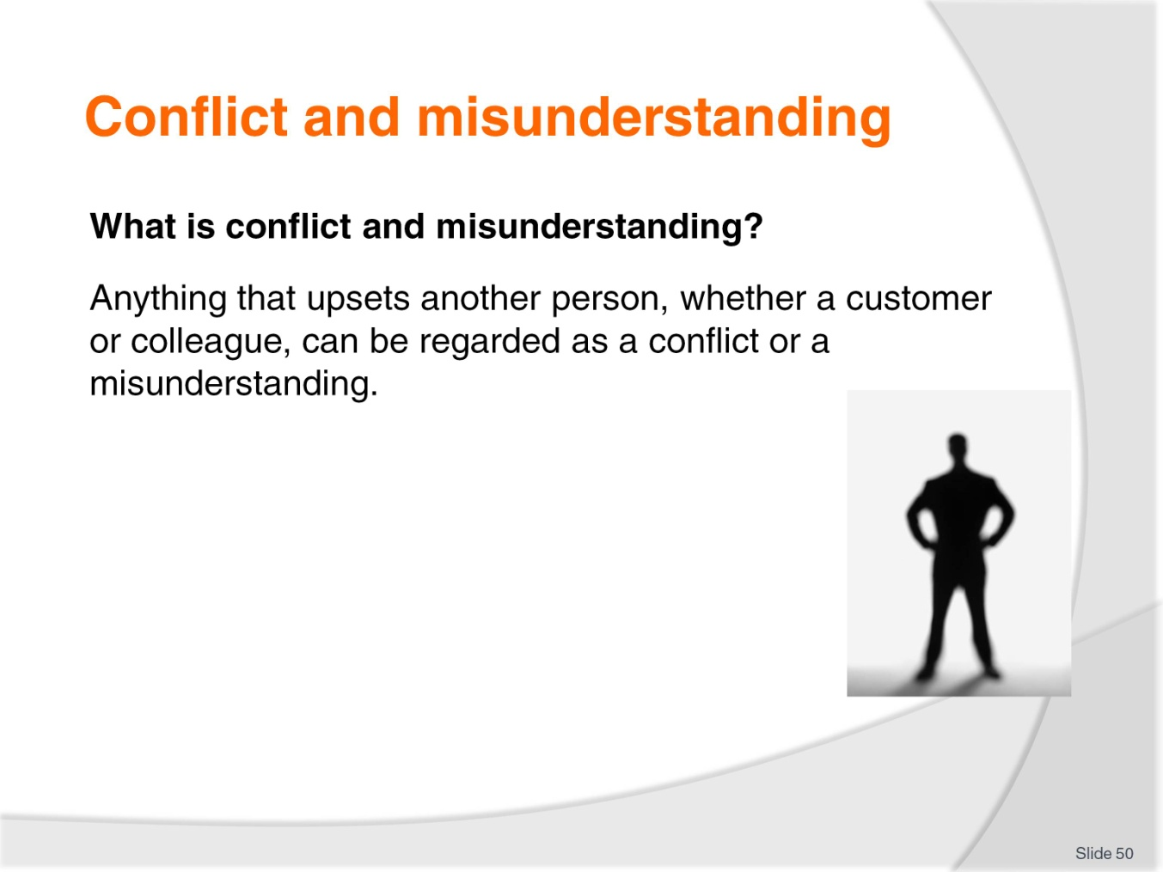
Slide No | Trainer Notes
Class Activity – Discussion
What are common conflicts you have in your private life?
What causes them?
How can they be solved?

Slide
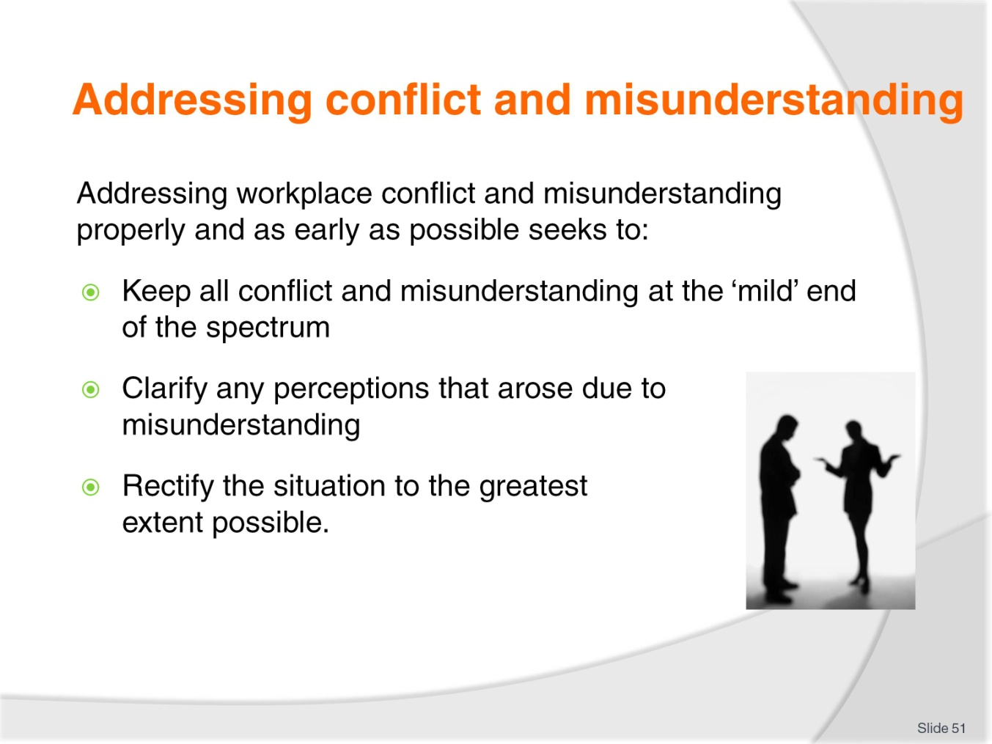
Slide No | Trainer Notes
Class Activity – Discussion
What are some ways to handle a conflict quickly?

Slide
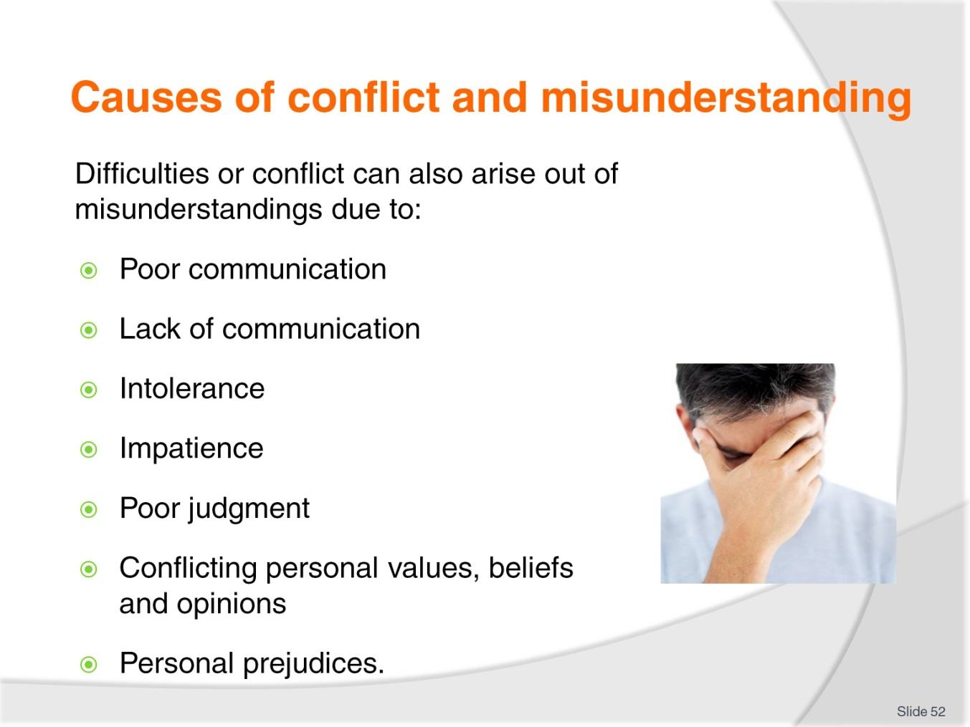
Slide No | Trainer Notes
Class Activity – Discussion
Get the audience to provide examples of conflict in each identified point.

Slide
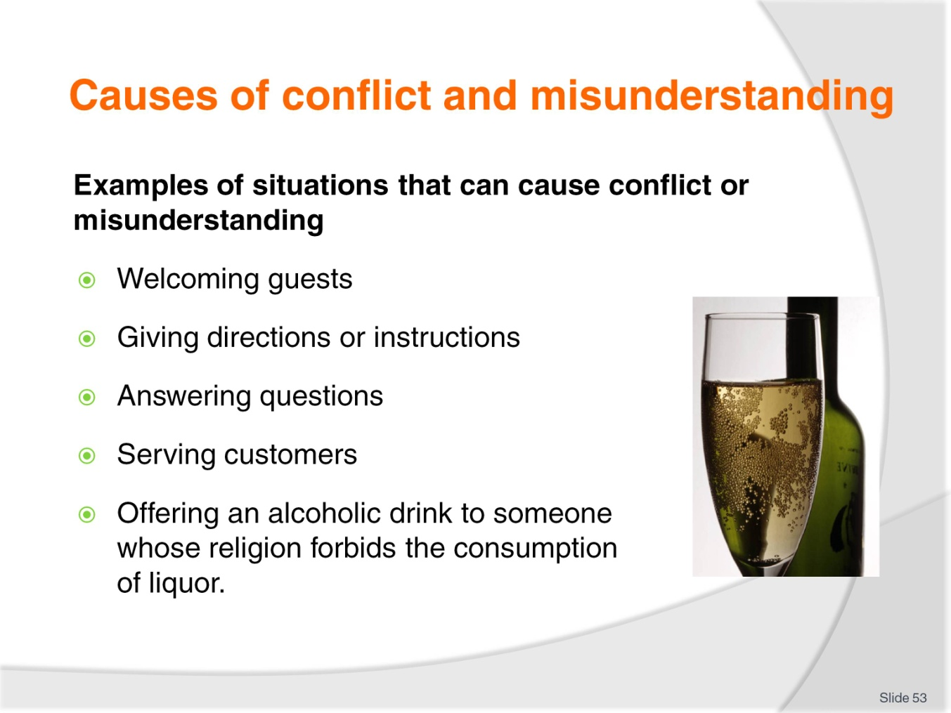
Slide No | Trainer Notes
Class Activity – Discussion
Get the audience to provide examples of conflict in each identified point.

Slide
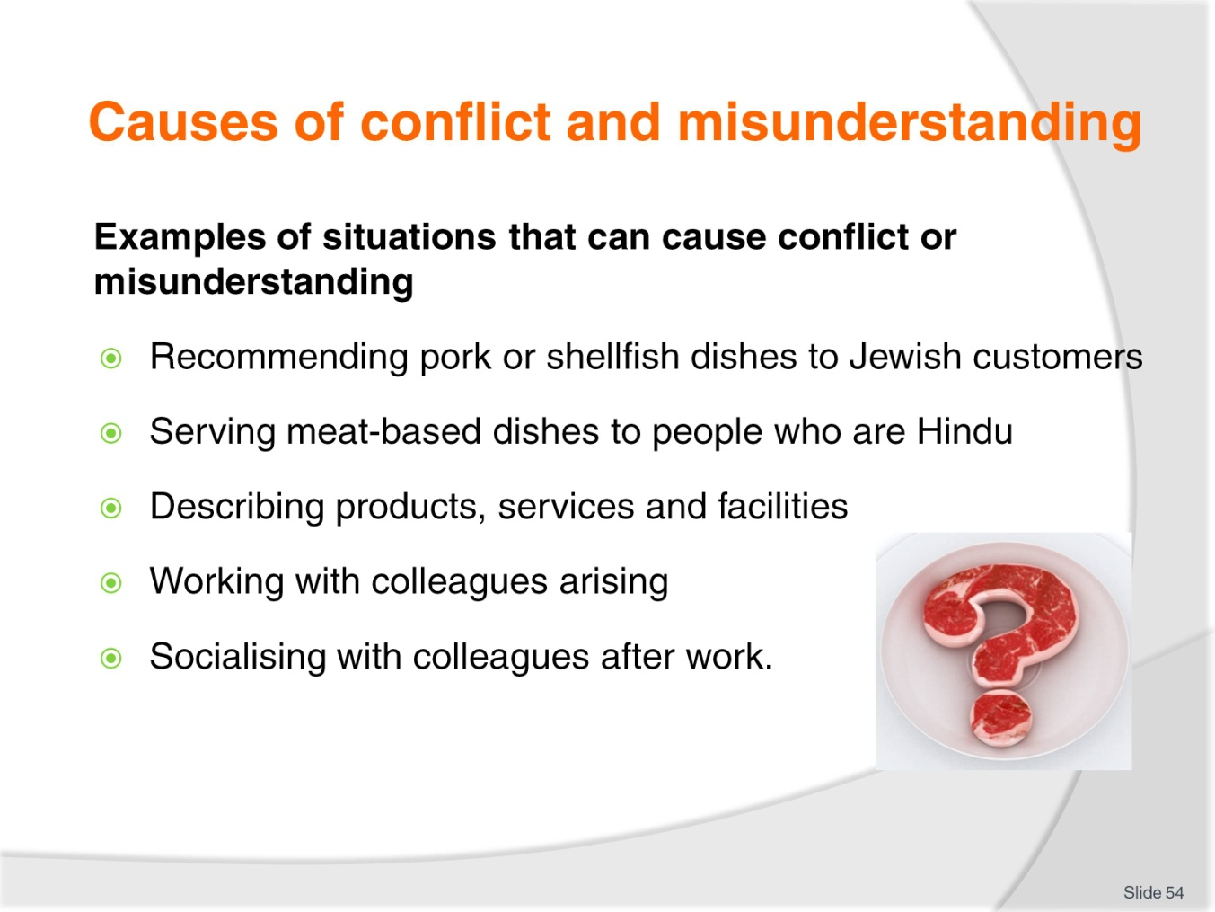
Slide No | Trainer Notes
Class Activity – Discussion
Get the audience to provide examples of conflict in each identified point.

Slide
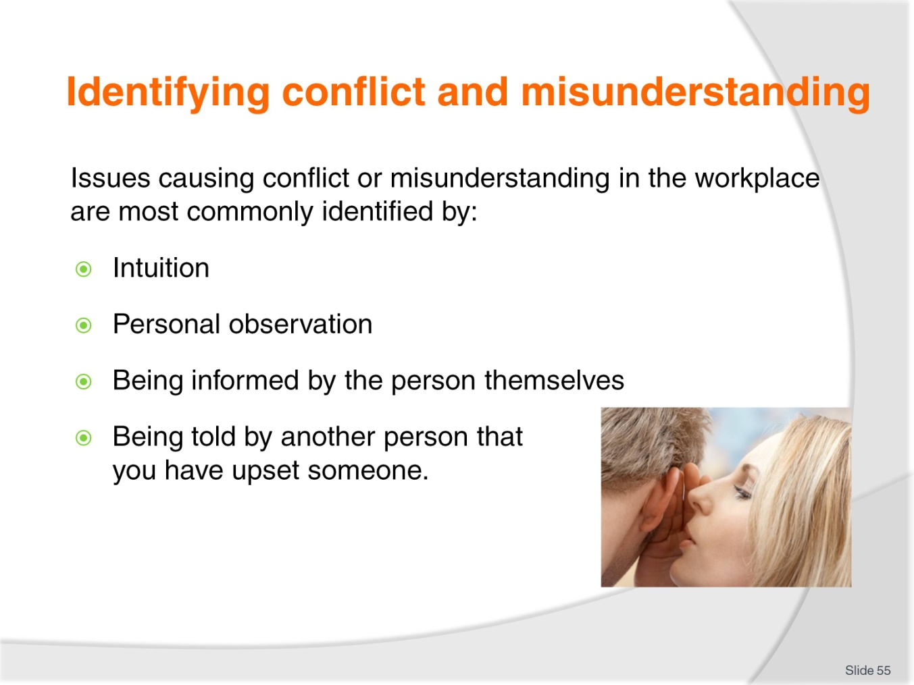
Slide No | Trainer Notes
Class Activity – Discussion
What is the best way to identify a conflict in your point of view?

Slide
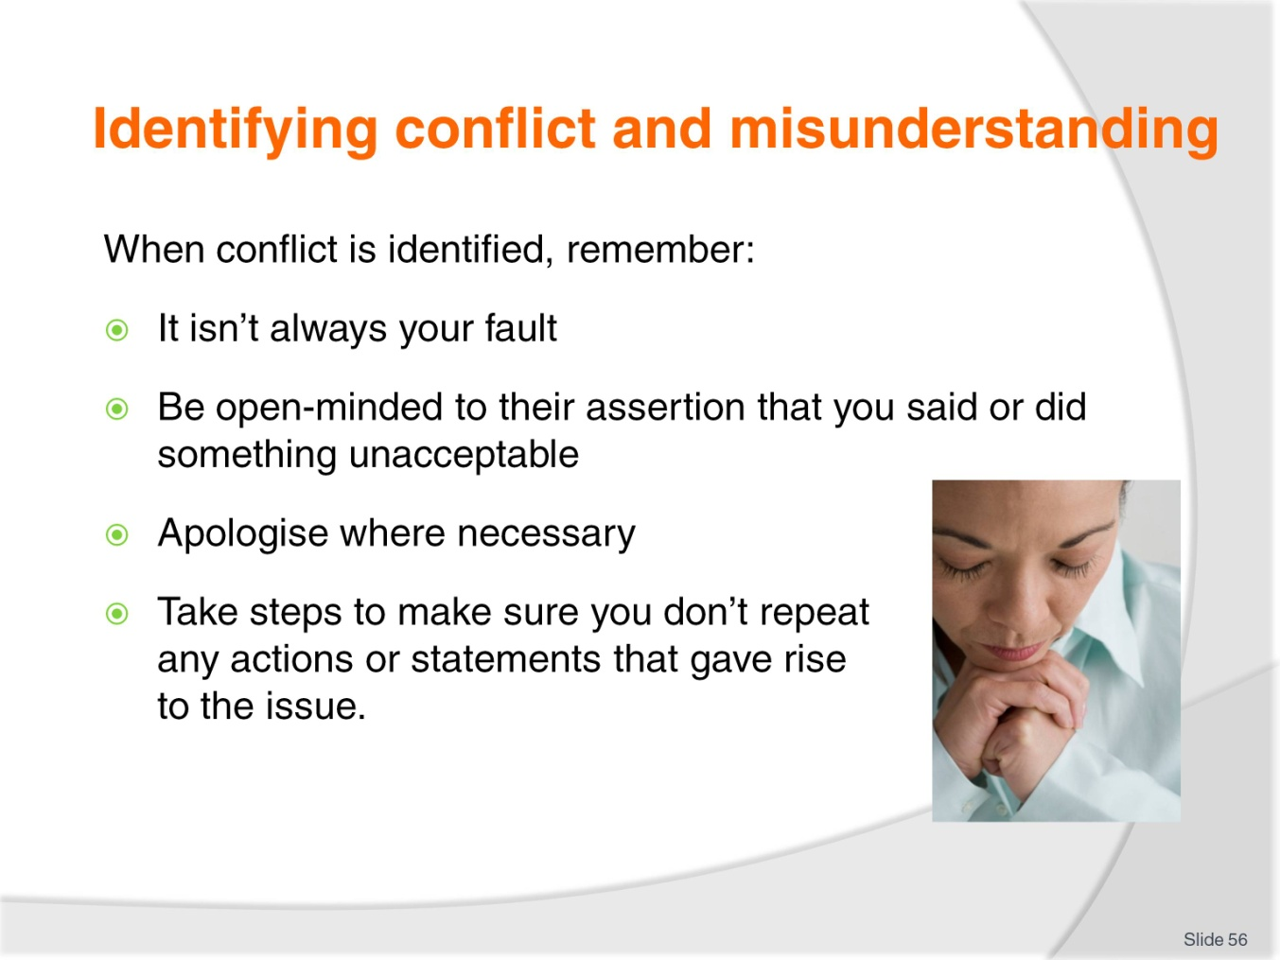
Slide No | Trainer Notes
It isn’t always your fault – the misunderstanding may be caused by their misinterpretation of facts or words.
Be open-minded to their assertion that you said or did something unacceptable – don’t immediately become defensive and start trying to defend a position that is essentially wrong or indefensible.
Apologise where necessary – it is truly amazing how many issues, disputes, misunderstandings and conflicts can be successfully resolved by a simple yet genuine and sincere apology.
Take steps to make sure you don’t repeat any actions or statements that gave rise to the issue – this should apply even where you believe you were genuinely not ‘at fault’. The crux of the decision to change your actions or words should not be whether you are, in fact right or wrong in what you said or did, but whether or not it actually gave offence or upset someone.

Slide
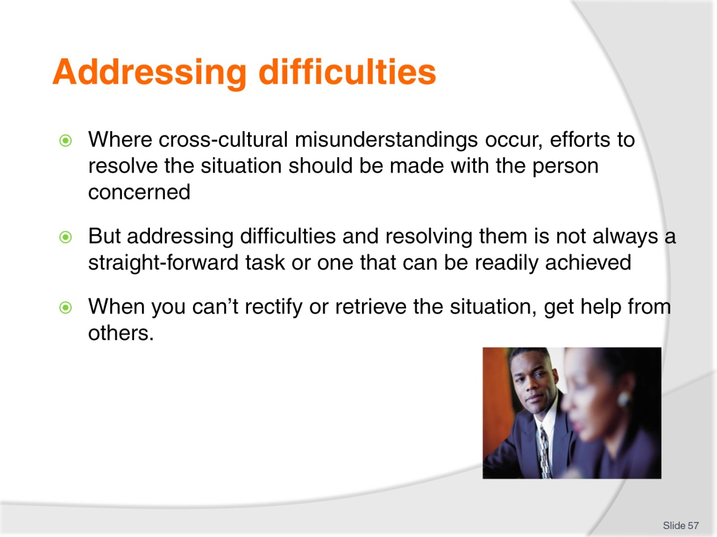
Slide No | Trainer Notes
Class Activity – Discussion
Why can’t a staff member solve all problems?
When would you get help from others?
Who would you go to for help?

Slide
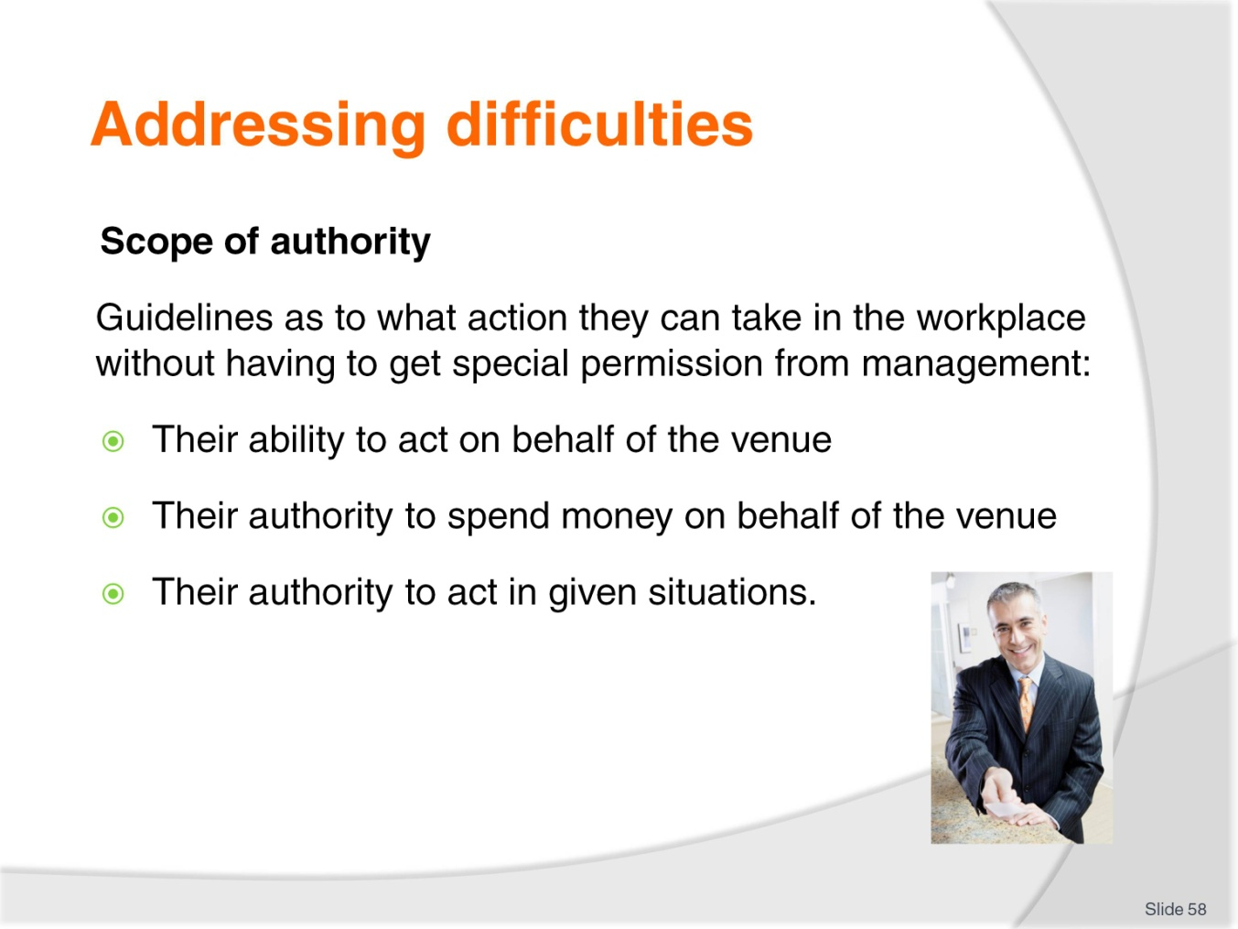
Slide No | Trainer Notes
Class Activity – Discussion
What scope of authority do line staff normally have when handling difficulties?

Slide
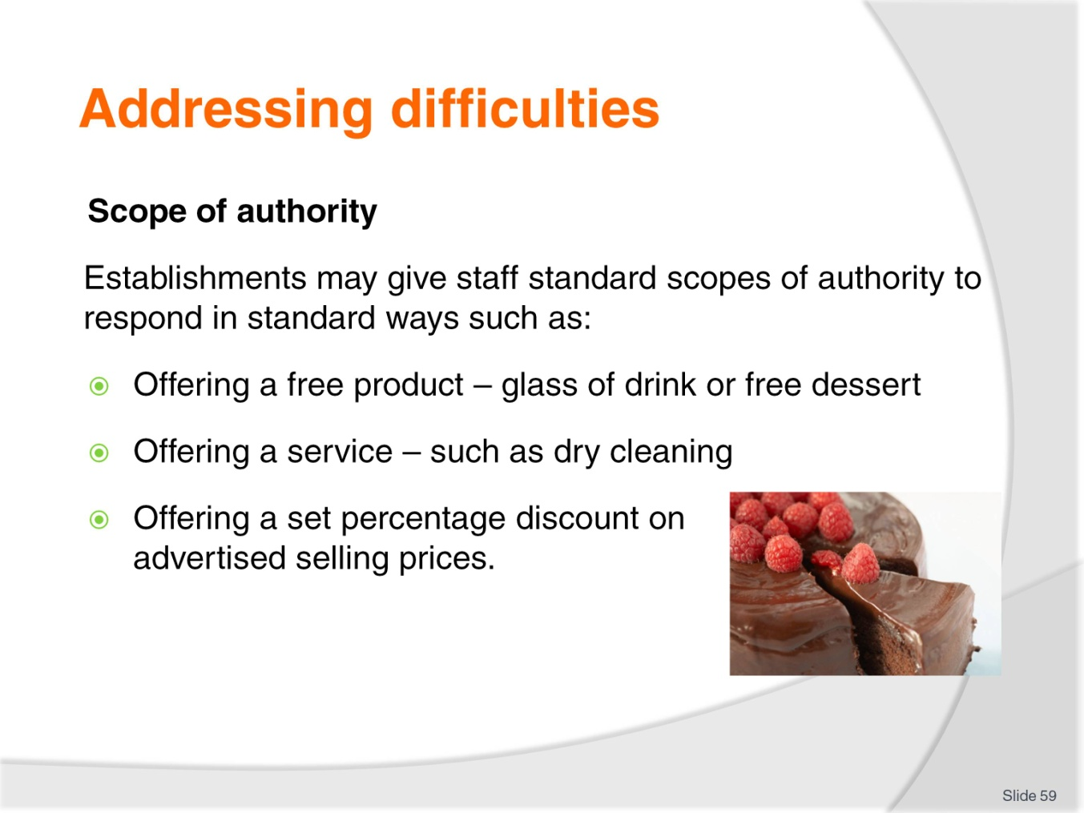
Slide No | Trainer Notes
Class Activity – Discussion
What are some examples in different departments?

Slide
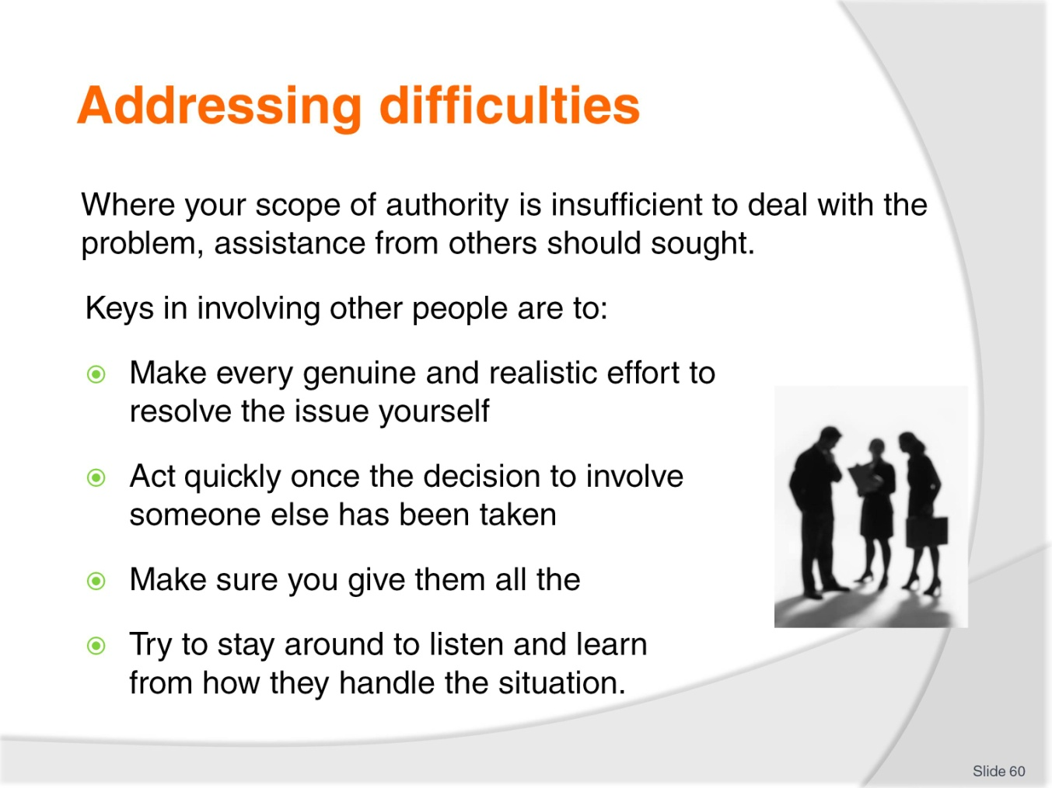
Slide No | Trainer Notes
Class Activity – Discussion
Discuss points.

Slide
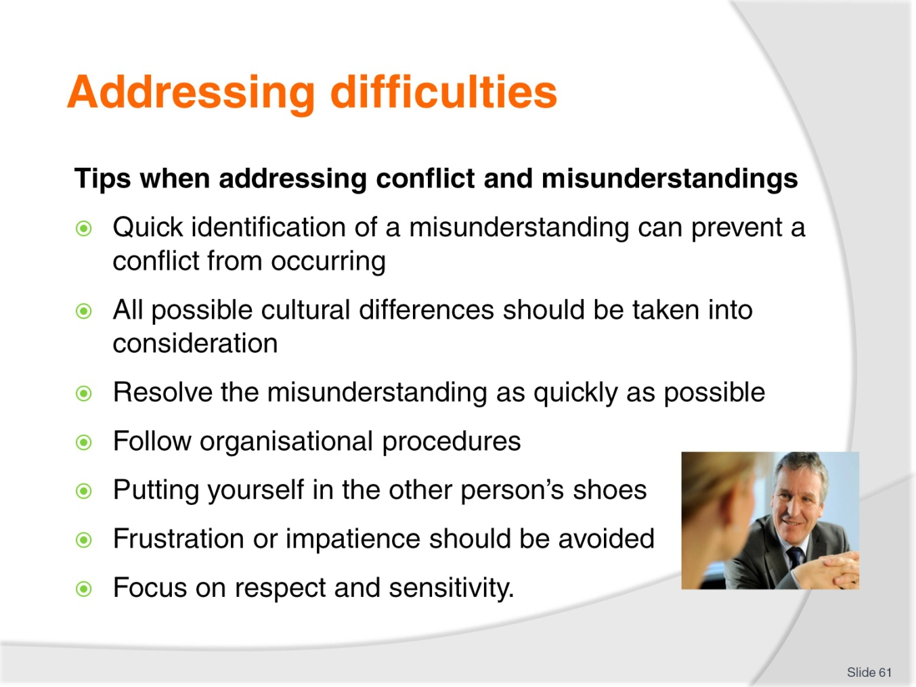
Slide No | Trainer Notes
Class Activity – Discussion
What are other tips you may have when addressing conflicts and misunderstandings?

Slide
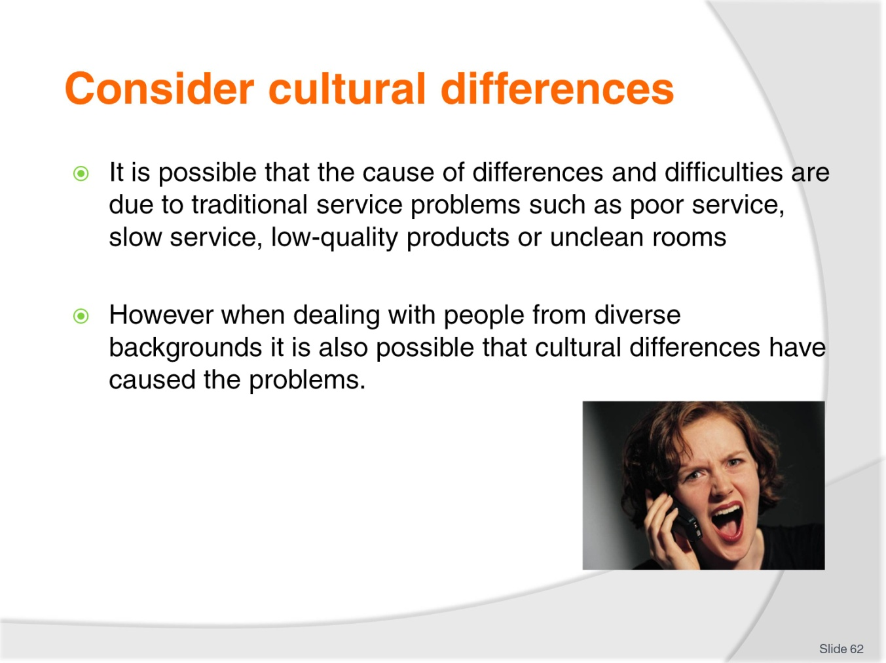
Slide No | Trainer Notes
Class Activity – Discussion
What are common cultural differences?

Slide
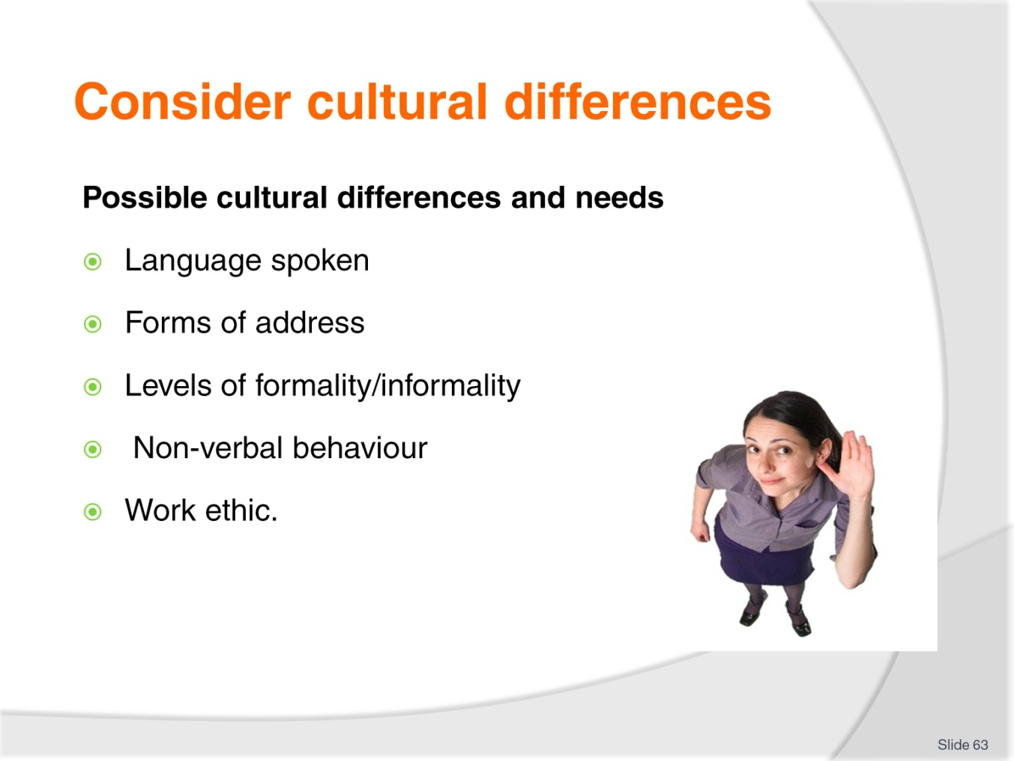
Slide No | Trainer Notes
Class Activity – Read and Discussion
Read the notes from the Training Manual in reference to these points. The relevant pages are 34-36.
Discuss how different cultures view the points in the slide and how it can cause conflict.

Slide
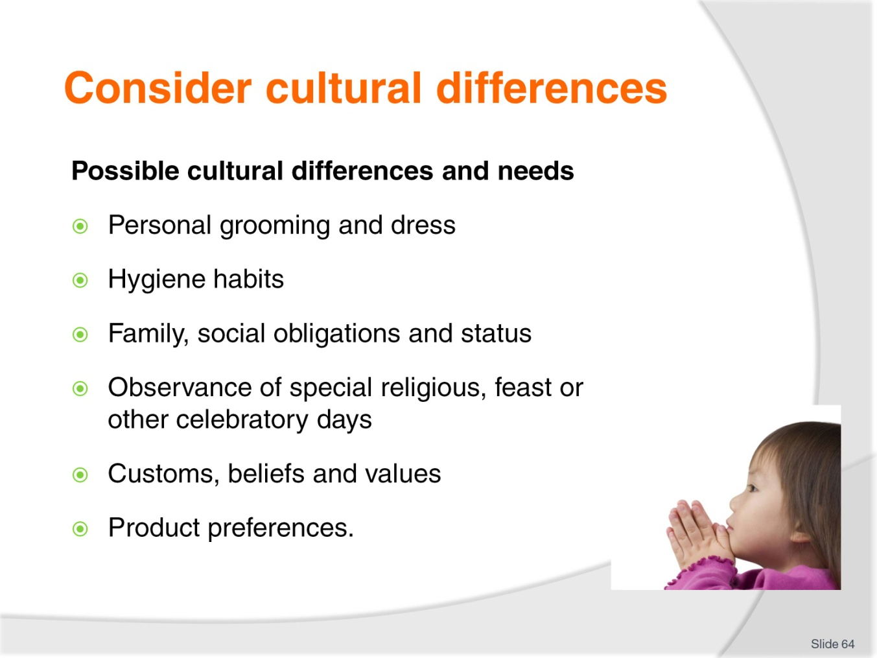
Slide No | Trainer Notes
Class Activity – Read and Discussion
Read the notes from the Training Manual in reference to these points. The relevant pages are 37 – 39.
Discuss how different cultures view the points in the slide and how it can cause conflict.

Slide
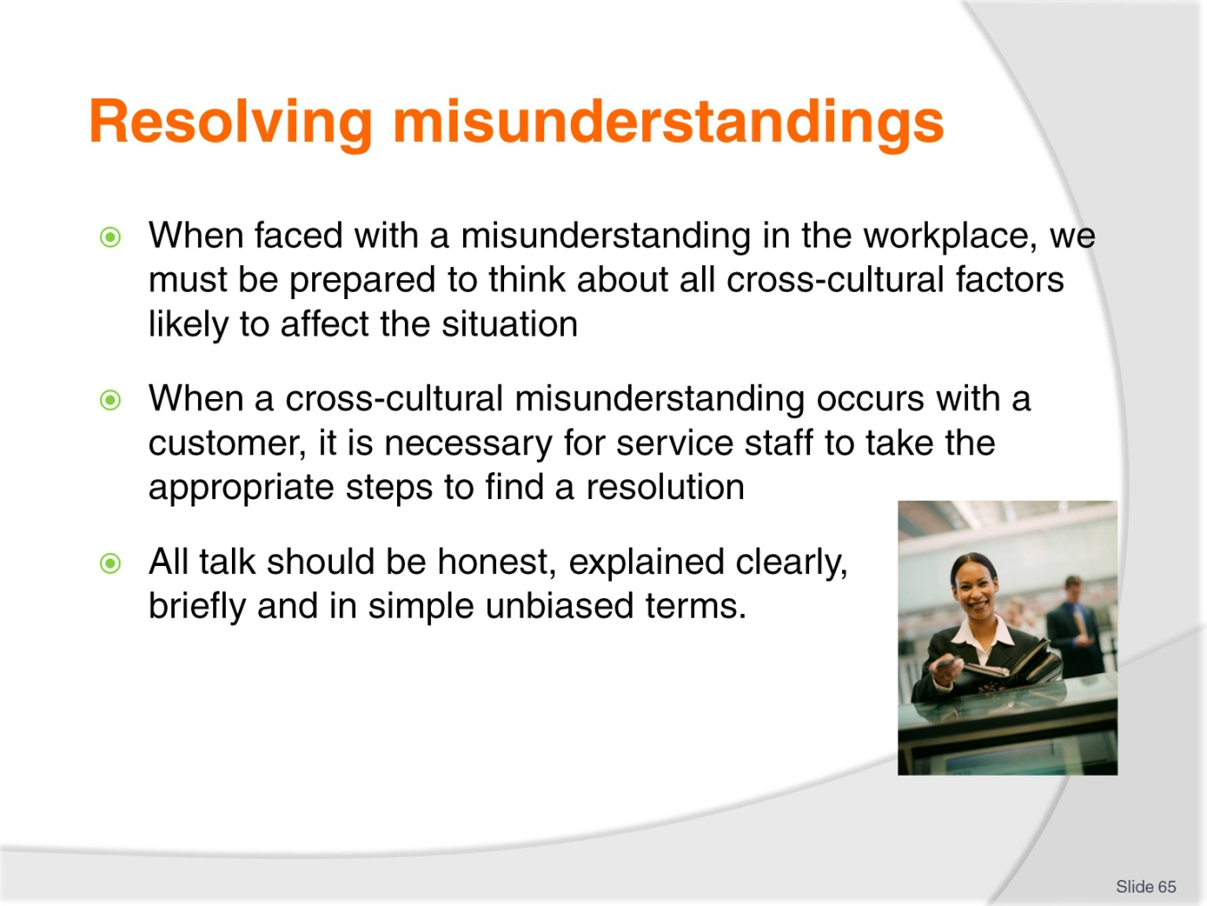
Slide No | Trainer Notes
Class Activity – Discussion
Think about conflicts that have occurred in the past. How did you resolve these misunderstandings?

Slide
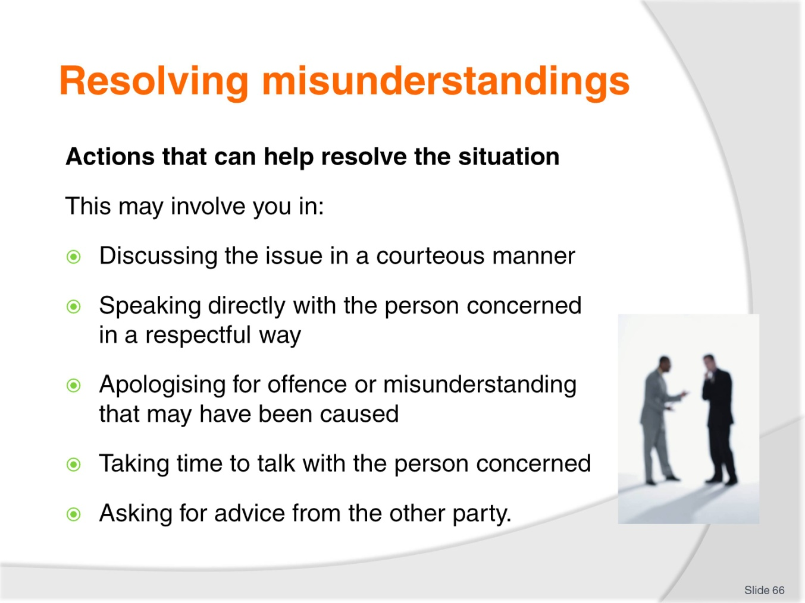
Slide No | Trainer Notes
Class Activity – Discussion
Discuss points.

Slide
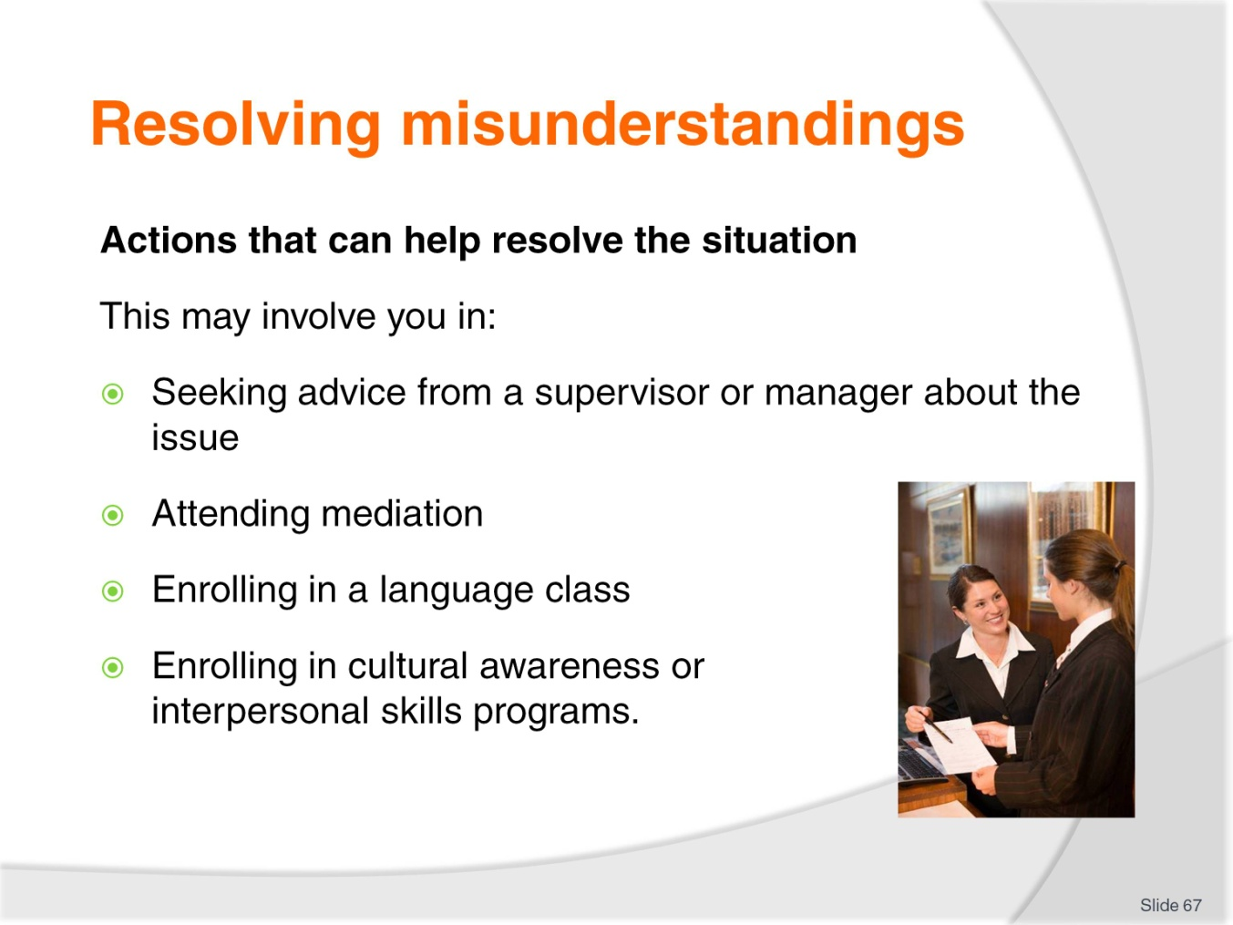
Slide No | Trainer Notes
Class Activity – Discussion
Discuss points.

Slide
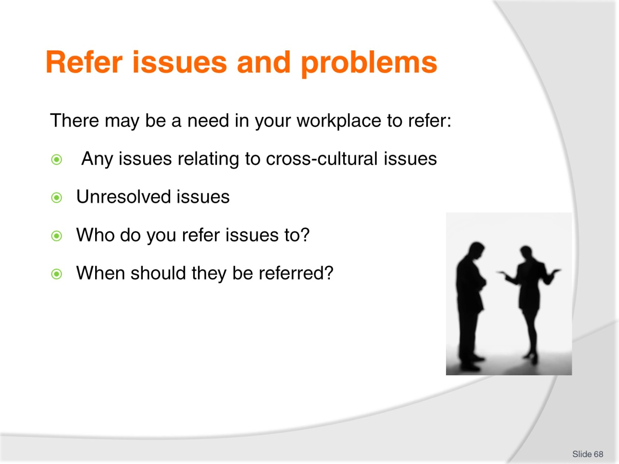
Slide No | Trainer Notes
Class Activity – Discussion
Discuss questions in the slide.

Slide
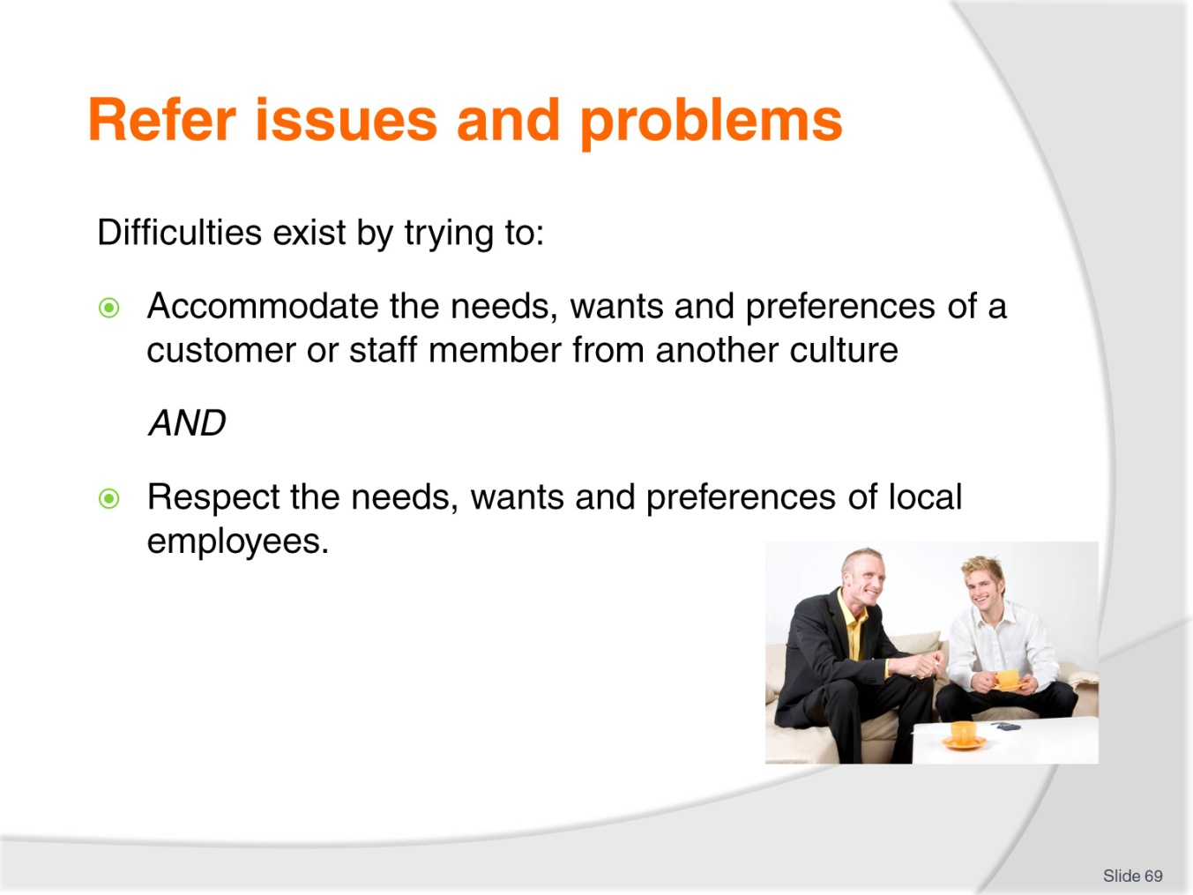
Slide No | Trainer Notes
Class Activity – Discussion
Provide examples of when it is hard to meet the needs of both the customer and the organisation and their staff.

Slide
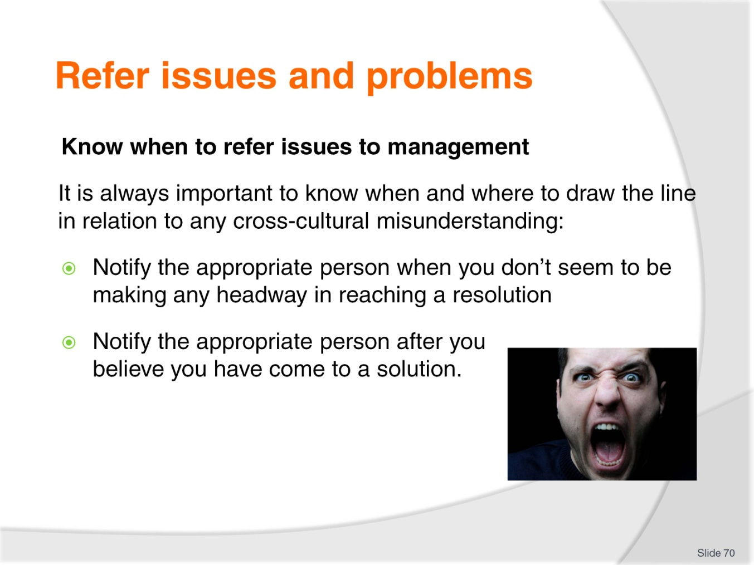
Slide No | Trainer Notes
Class Activity – Discussion
What is ‘your line’ when it is time to stop handling a situation and to refer it to someone else?

Slide
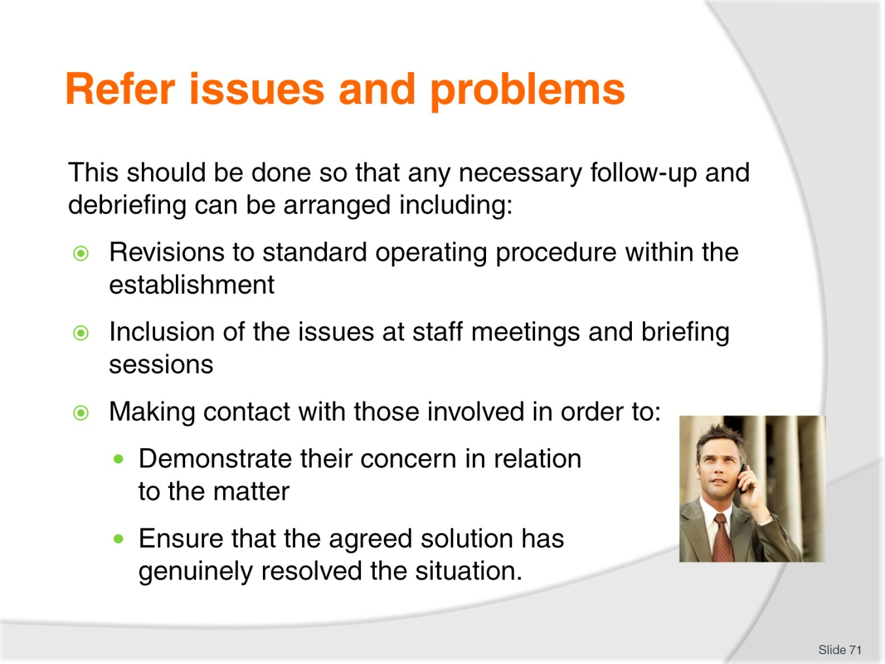
Slide No | Trainer Notes
Class Activity – Discussion
Discuss point.

Slide
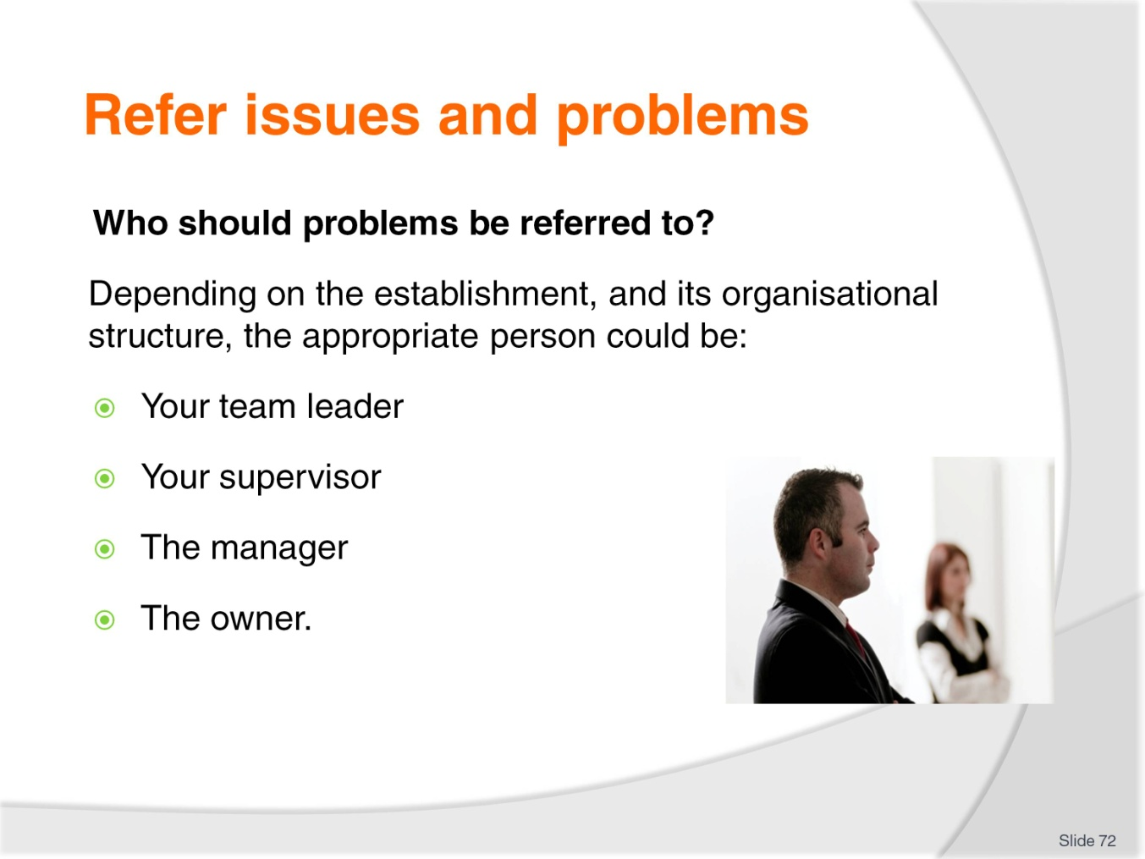
Slide No | Trainer Notes
Class Activity – Discussion
What is the protocol of referring issues?
Is the team leader or supervisor the first contact point or can you go higher?
When do you do higher?

Slide

Slide No | Trainer Notes
This is the conclusion of the subject.
Thank the audience and deliver assessments as required.

Recommended training equipment
- Communication documents used in workplace, including menus, compendiums, brochures and other materials for use by guest (in different languages)
- Computer with internet and email access
- DVD’s and written documents relating to cross cultural communications
- Embassy and Consulate information regarding different countries
- Emergency procedures
- Equal Employment legislation
- Equipment manuals
- Information on different countries
- Lonely Planet booklets
- OHS documents
- Note pads and pens
- Posters (in different languages)
- Safety Signs (in different languages)
- Scope of Authority examples for staff at all levels dealing with complaints
- Standard Operating Procedures (SOP’s).

Instructions for Trainers for using
PowerPoint – Presenter View
Connect your laptop or computer to your projector equipment as per manufacturers’ instructions.
In PowerPoint, on the Slide Show menu, click Set Up Show.
Under Multiple monitors, select the Show Presenter View check box.
In the Display slide show on list, click the monitor you want the slide show presentation to appear on.
Source: http://office.microsoft.com
Note:
In Presenter View:
You see your notes and have full control of the presentation
Your trainees only see the slide projected on to the screen
More Information
You can obtain more information on how to use PowerPoint from the Microsoft Online Help Centre, available at: http://office.microsoft.com/training/training.aspx?AssetID=RC011298761033
Note Regarding Currency of URLs
Please note that where references have been made to URLs in these training resources trainers will need to verify that the resource or document referred to is still current on the internet. Trainers should endeavour, where possible, to source similar alternative examples of material where it is found that either the website or the document in question is no longer available online.

Appendix – ASEAN acronyms
AADCP | ASEAN – Australia Development Cooperation Program.
ACCSTP | ASEAN Common Competency Standards for Tourism Professionals.
AEC | ASEAN Economic Community.
AMS | ASEAN Member States.
ASEAN | Association of Southeast Asian Nations.
ASEC | ASEAN Secretariat.
ATM | ASEAN Tourism Ministers.
ATPMC | ASEAN Tourism Professionals Monitoring Committee.
ATPRS | ASEAN Tourism Professional Registration System.
ATFTMD | ASEAN Task Force on Tourism Manpower Development.
CATC | Common ASEAN Tourism Curriculum.
MRA | Mutual Recognition Arrangement.
MTCO | Mekong Tourism Coordinating office.
NTO | National Tourism Organisation.
NTPB | National Tourism Professional Board.
RQFSRS | Regional Qualifications Framework and Skills Recognition System.
TPCB | Tourism Professional Certification Board.







